INDEX
S.R. NO | NAME OF  EXPERIMENT | Date of performance | Experiment marks | Teacher’s signature
1. | To verify the momentum equation using the experimental set-up on impact of jet.
2. | To determine the coefficient of discharge of an orifice of a given shape. Also to determine the coefficient of velocity and the coefficient of contraction of the orifice mouth piece.
3. | To calibrate an orifice meter and study the variation of the co-efficient of discharge with the Reynolds number
4. | To calibrate a Venturimeter and study the variation of the co-efficient of discharge with the Reynolds number.
5. | To determine Meta-centric height of a given ship model.
6. | To study the transition from laminar to turbulent flow and to determine the lower critical Reynolds number.
7. | To study the variation of friction factor, ‘f’ for turbulent flow in commercial pipes.
8. | To determine the head loss for a sudden enlargement
9. | To determine the head loss for a sudden Contraction.
10. | To determine the coefficient of discharge of an orifice of a given shape. Also to determine the coefficient of velocity and the coefficient of contraction of the orifice mouth piece.

EXPERIMENT NO.: 01

Objective:-
To verify the momentum equation using the experimental set-up on impact of jet.
Apparatus Used:-

Collecting tank, Transparent cylinder, Two nozzles of dia 10 mm & 12mm, Vane of different shape (flat, inclined or curved).

Principle:-
Momentum equation is based on Newton’s second law of motion which states that the algebraic sum of external forces applied to control volume of fluid in any direction is equal to the rate of change of momentum in that direction. The external forces include the component of the weight of the fluid & of the forces exerted externally upon the boundary surface of the control volume. If a vertical water jet moving with velocity is made to strike a target, which is free to move in the vertical direction then a force will be exerted on the target by the impact of jet, according to momentum equation this force (which is also equal to the force required to bring back the target in its original position) must be equal to the rate of change of momentum of the jet flow in that direction.
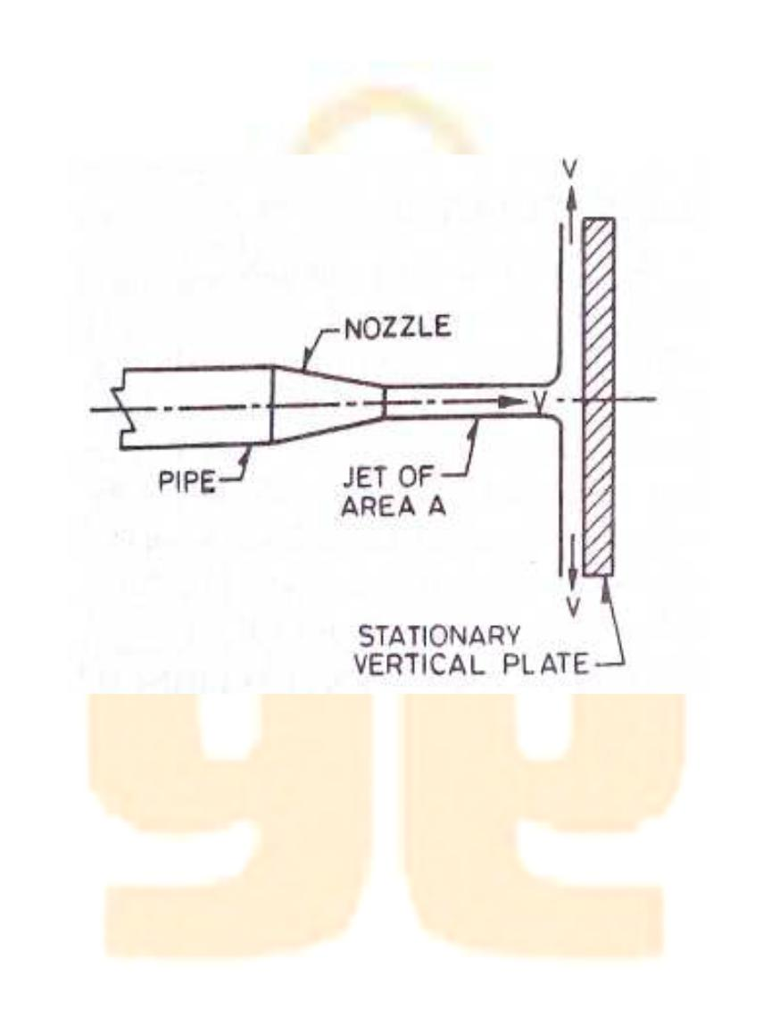

Figure: Impact of jet

Formula Used:-
F'=ρQ v(1-cosβ)
F'=ρQ2(1-cosβ) as v=Q/a
Where F' =force (calculated)
ρ= density of water
β=angle of difference vane
V =velocity of jet angle
Q =discharge
A =area of nozzle ( π/4d2)
- for flat vane β=90 F = ρQ2/a
- for hemispherical vane β=180o for % error =F- F'/F'x100
F = 2 ρQ2/a
F = Force (due to putting of weight)
iii)for inclined vane
F'=ρQ v(1-cosβ)
F'=ρQ2(1-cosβ)

Procedure:-
- Note down the relevant dimension or area of collecting tank, dia of nozzle, and density of water.
- Install any type of vane i.e. flat, inclined or curved.
- Install any size of nozzle i.e. 10mm or 12mm dia.
- Note down the position of upper disk, when jet is not running.
5 Note down the reading of height of water in the collecting tank.
- As the jet strike the vane, position of upper disk is changed, note the reading in the scale to which vane is raised.
- Put the weight of various values one by one to bring the vane to its initial position.
- At this position finds out the discharge also.
- The procedure is repeated for each value of flow rate by reducing the water supply.
- This procedure can be repeated for different type of vanes and nozzle.
Observations:-
Dia of nozzle =
Mass density of water ρ=
Area of collecting tank =
Area of nozzle =

Horizontal flat vane:

When jet is not running, position of upper disk is at=

Sr. | Discharge measurement |  |  |  | Balancing |  | Theoretical | Error | in%
No. | Initial | Final | Time | Discharge | Mass | Force | force | =(F-F’)/F’
 | (cm.) | (cm.) | (sec) | Q (cm³/sec) | (gm) | F(dyne) | F’= ρQ²/a
1.
2.
3.

Inclined vane:

When jet is not running, position of upper disk is at=
Angle of inclination β=45º
Sr. | Discharge measurement |  |  |  | Balancing |  | Theoretical | Error | in%
No. | Initial | Final | Time | Discharge | Mass | Force | force | =(F-F’)/F’
 | (cm.) | (cm.) | (sec) | Q (cm³/sec) | (gm) | F(dyne) | F’= ρQ²(1-
 |  |  |  |  |  |  | cosβ)/a
1.
2.
3.

Result:- The value of impact of jet from the given table is=
Safety Precautions:-
- Water flow should be steady and uniform.
- The reading on the scale should be taken without any error.
- The weight should be put slowly & one by one.
- After changing the vane the flask should be closed tightly.

EXPERIMENT NO.: 02
Objective:-
To determine the coefficient of discharge of an orifice of a given shape. Also to determine the coefficient of velocity and the coefficient of contraction of the orifice mouth piece.
Apparatus Used:-
Supply tank with overflow arrangement, Orifice plate of different diameter, hook gauge, collecting tank, piezometric tube.
Principle:-
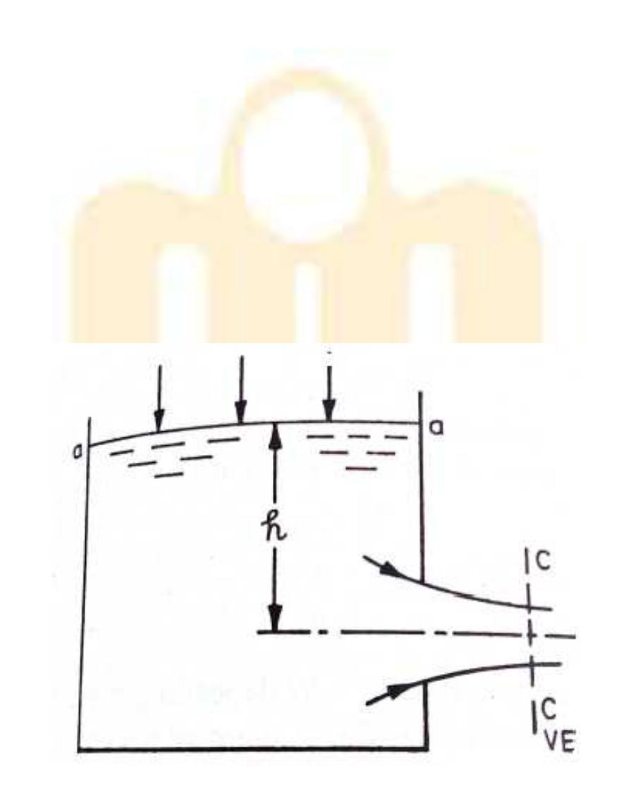
A mouthpiece is a short length of pipe which is two or three times its diameter in length. If there pipe is filled externally to the orifices, the mouthpiece is called external cylindrical mouthpiece and discharge through orifice increase is a small opening of any cross-section on the side of bottom of the tank, through which the fluid is flowing orifice coefficient of velocity is defined as the ratio of two actual discharge to orifice ratio of the actual velocity of the jet at vena- contracta to the coefficient of theoretical velocity of the jet coefficient of contraction of defined as ratio of the actual velocity of jet at vena- contracta.

Vena- Contracta:- The fluid out is in form of jet goes on contracting form orifice up todispute of about ½ the orifice dia. After the expend this least relation.
Coefficient of velocity:- It is a ratio of actual velocity jet at vena-contracta to theoretical velocity.

Figure: Flow through Orifice
Procedure:-
- Set the mouthpiece of orifice of which the Cc, Cu, Cd are to be determined.

- Note the initial height of water in the steady flow tank and the height of datum from the bottom of orifice and mouthpiece. These remains constant for a particular mouthpiece or orifice.

- By using the stop valve, set a particular flow in tank and tank height of water in tank.

- Take the reading of discharge on this particular flow.

- Using hook gauge, find the volume of Xo Y for mouthpiece.

- Take three readings using hook gauge for one particular orifice.

- Using the formula get value of Cd, Cu, and Cc for a particular orifice and mouthpiece.

Observation:-
x' + y' are reading on horizontal/vertical scale

a_{o} | h=µa _{o} | x’ | y’ | X=x’-x _{o}y | Y=y’-y_{o} | C_{u}=x/2gh | Average

h = Reading on piezometer

a0 = Reading on piezometer at level on centre of mouthpiece

y0 = Reading on vertical scale at exit of orifice

x0 = Reading on horizontal scale at exit of orifice.

Result:-
Precautions:-

- Take the reading of discharge accurately.

- Take value of h without any parallax error.

- Set the orifice and mouthpiece.

- Height of water in the steady flow.

- Take reading from hook gauge carefully.

EXPERIMENT NO.: 03
Objective:-
To calibrate an orifice meter and study the variation of the co-efficient of discharge with the Reynolds number.
Apparatus Used:-
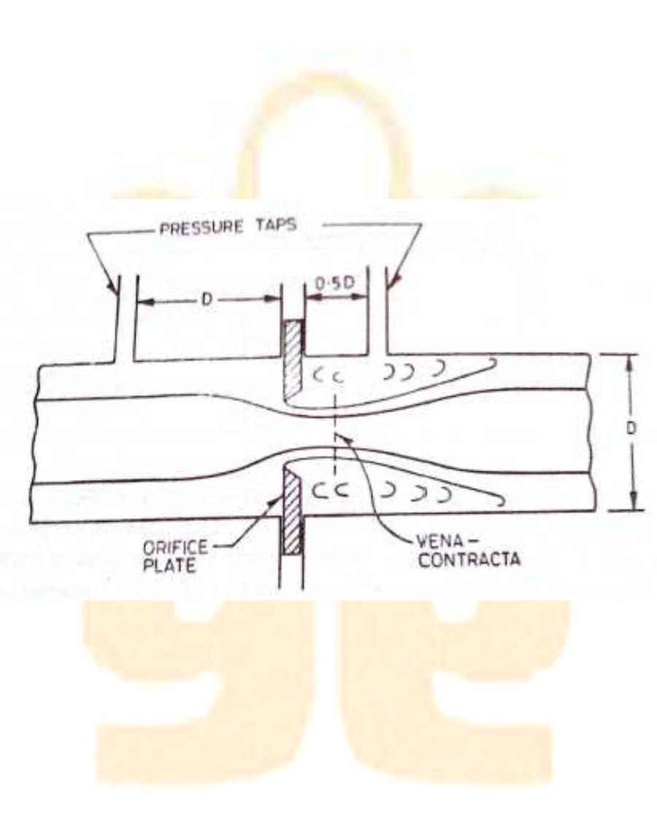
Orifice meter, installed on different pipes, arrangement of varying flow rate, U- tube manometer, collecting tube tank, vernier calliper tube etc.
Theory:-
Orifice meter are depending on Bernoulli’s equation. Orificemeter is a device used for measuring the rate of fluid flowing through a pipe. It is a cheaper device than Venturimeter.

Figure: Orificemeter
Formula Used: -
Q = C_{d}aA√2gh/√(A²-a²)
Where
A = Cross section area of inlet
a = Cross section area of outlet
h = Head difference in manometer
Q = Discharge
Cd = Coefficient of discharge
g = Acceleration due to gravity

Procedure:-

- Set the manometer pressure to the atmospheric pressure by opening the upper valve.

- Now start the supply at water controlled by the stop valve.

- One of the valves of any one of the pipe open and close all other of three.

- Take the discharge reading for the particular flow.

- Take the reading for the pressure head on from the u-tube manometer for corresponding reading of discharge.

- Now take three readings for this pipe and calculate the Cd for that instrument using formula.

- Now close the valve and open valve of other diameter pipe and take the three reading for this.

- Similarly take the reading for all other diameter pipe and calculate Cd for each.

Observations:-
Diameter of Orifice meter =
Area of cross section =
Area of collecting tank=
 |  | Discharge |  |  |  | Manometer reading
(cm.) | (cm) |  | (sec) |  |  |  | H₁ | H₁) | = | . √ | −
Initial | Final | Difference | Time | Discharge | H1 | H2 | H₂- | h=13.6(H₂-
 |  |  |  |  |  |  |  |  |  | . . 2∆

Result:-
Precautions:-
- Keep the other valve closed whiletaking reading through one pipe.

- The initial error in the manometer should be subtracted final reading.

- The parallax error should be avoided.

- Maintain a constant discharge for each reading.

- The parallax error should be avoided while taking reading the manometer.

EXPERIMENT NO.: 04
Objective:-
To calibrate a Venturimeter and study the variation of the co-efficient of discharge with the Reynolds number.

Apparatus Used:-
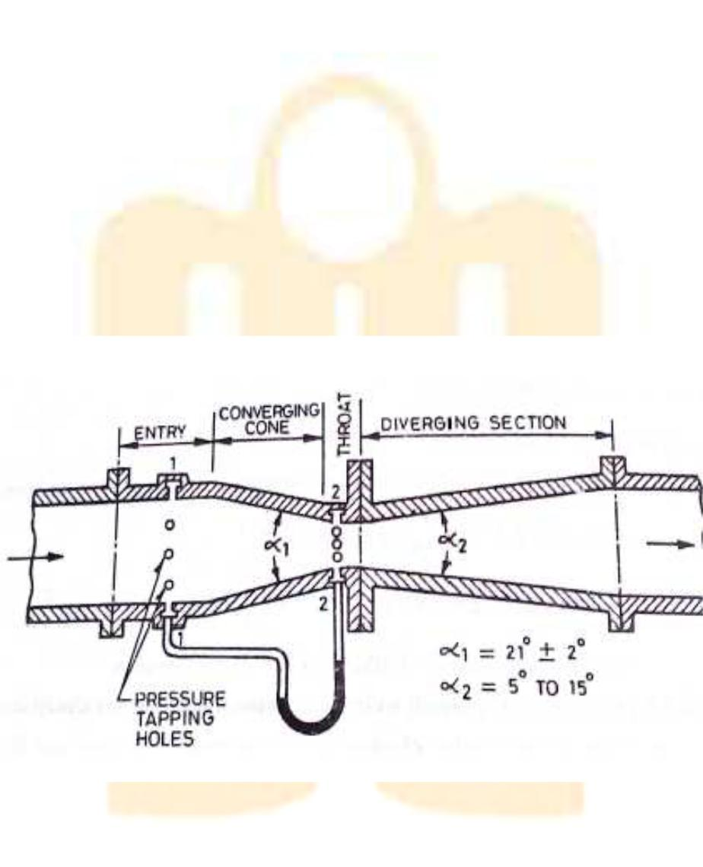
Venturimeter, installed on different diameter pipes, arrangement of varying flow rate, U- tube manometer, collecting tube tank, vernier calliper tube etc.
Theory:-
Venturimeter are depending on Bernoulli’s equation . Venturimeter is a device used for measuring the rate of fluid flowing through a pipe. The consist of three part in short

- Converging area part

- Throat

- Diverging part

Figure: Venturimeter

Formula Used: -
Q = C_{d}aA√2gh/√(A²-a²)
Where
A = Cross section area of inlet
a = Cross section area of outlet
h = Head difference in manometer
Q = Discharge
Cd= Coefficient of discharge
g = Acceleration due to gravity

Procedure:-

- Set the manometer pressure to the atmospheric pressure by opening the upper valve.

- Now start the supply at water controlled by the stop valve.

- One of the valves of any one of the pipe open and close all other of three.

- Take the discharge reading for the particular flow.

- Take the reading for the pressure head on from the u-tube manometer for corresponding reading of discharge.

- Now take three readings for this pipe and calculate the Cd for that instrument using formula.

- Now close the valve and open valve of other diameter pipe and take the three reading for this.

- Similarly take the reading for all other diameter pipe and calculate Cd for each

Observations:-

Diameter of Venturimeter=

Area of cross section =

Venturimeter=

Area of collecting tank=

 |  | Discharge |  |  |  | Manometer reading
(cm.) | (cm) |  | (sec) |  |  |  | H1 | H₁) | = | . √ | −
Initial | Final | Difference | Time | Discharge | H₁ | H₂ | H₂- | h=13.6(H₂-
 |  |  |  |  |  |  |  |  |  | . . 2∆
Result:-
Precautions:-
1.Keep the other valve closed while taking reading through one pipe.

2.The initial error in the manometer should be subtracted final reading.

3.The parallax error should be avoided.

4.Maintain a constant discharge for each reading.

5.The parallax error should be avoided while taking reading the manometer.

EXPERIMENT NO.: 05
Objective:-
To determine Meta-centric height of a given ship model.

Apparatus Used:-
Take tank 2/3 full of water, floating vessel or pontoon fitted with a pointed pointer moving on a graduated scale, with weights adjusted on a horizontal beam.
Principle:-
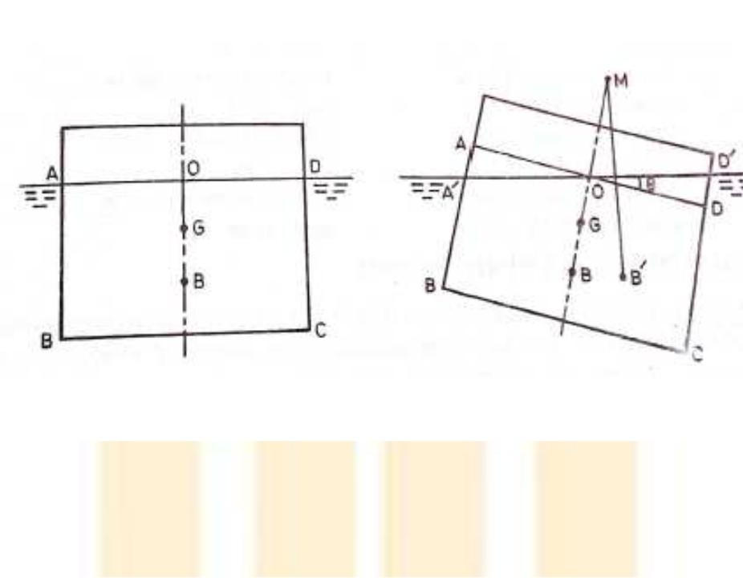

Figure: Metacentric Height apparatus

Consider a floating body which is partially immersed in the liquid, when such a body is tilted, the center of buoyancy shifts from its original position ‘B’ to ‘B’ (The point of application of buoyanant force or upward force is known as center of G which may be below or above the center of buoyancy remain same and couple acts on the body. Due to this couple the body remains stable. At rest both the points G and B also Fb x Wc act through the same vertical line but in opposite direction. For small change (θ) B shifted to B.
The point of intersection M of original vertical line through B and G with the new vertical, line passing through ‘B’ is known as metacentre. The dis tance between G and M is known as metacentre height which is measure of static stability.
Formula used-

Where: -
Wm is unbalanced mass or weight.
Wc is weight of pontoon or anybody.
Xd is the distance from the center of pointer to striper or unbalanced weight.

- is angle of tilt or heel.

Procedure:-
- Note down the dimensions of the collecting tank, mass density of water.

- Note down the water level when pontoon is outside the tank.

- Note down the water level when pontoon is inside the tank and their difference.

- Fix the strips at equal distance from the center.

- Put the weight on one of the hanger which gives the unbalanced mass.

- Take the reading of the distance from center and angle made by pointer on arc.

- The procedure can be repeated for other positioned and values of unbalanced mass.

Observation Table:-
Length of the tank =
Width of the tank =
Area of the tank =
Initial level of the water without pontoon X₁ =
Final level of the water with pontoon X₂ =
Difference in height of water (X) = X2–X1=
Height | of | Difference | Weight of | Unbalanced | Q | GM=Metacentric | Xd (m)
water | in | in height | pontoon | massW_{m} |  | Height (m)
tank | with | X=X₂-X₁ | W_{c}=XAρ | Kg
pontoon X₂

Result:- Meta centric height of the pontoon is measured with different positions and weights and value is………….

Precautions:-
- The reading taking carefully without parallax error.

- Put the weight on the hanger one by one.

- Wait for pontoon to be stable before taking readings.

- Strips should be placed at equal distance from the centre.

EXPERIMENT NO.: 06
Objective:-

To study the transition from laminar to turbulent flow and to determine the lower critical Reynolds number.
Apparatus Used:-
Flow condition inlet supply, elliptical belt type arrangement for coloured fluid with regulating valve, collecting tank.
Principle:-
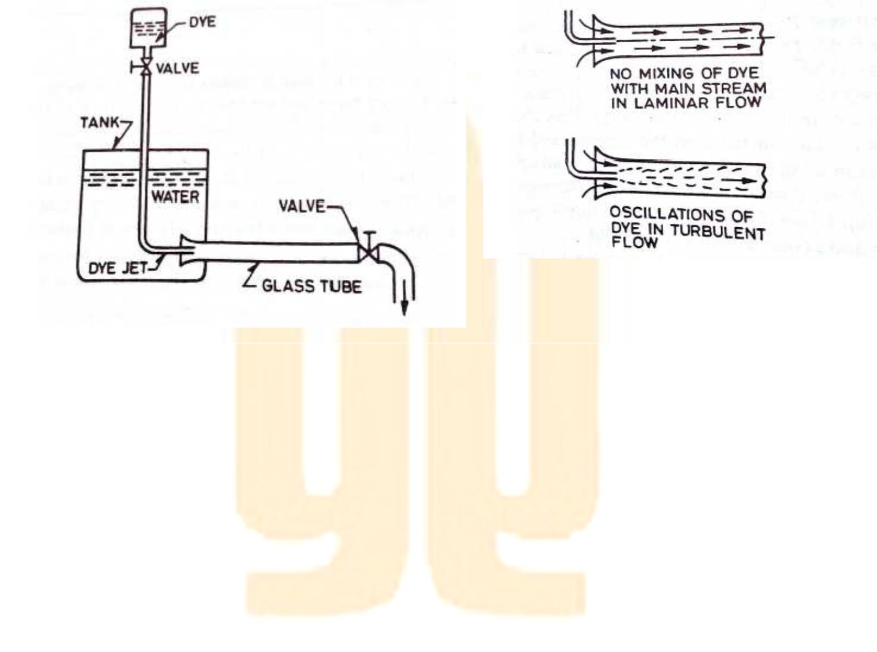

Figure: Reynold No. apparatus

Reynolds Number:- It is defined as ratio of inertia force of a flowing fluid and the viscous force
of the fluid. The expression for
Reynolds number is obtained as:-
Inertia force (Fi) = mass . acceleration of flowing
- δ. Volume. Velocity/ time
  - δ. ^{+5*3L4}_{27L4}Velocity

  - δ.area .Velocity . Velocity
  - δ.A .V²
Viscous force (Fv) = Shear stress . area

- τ. A
- μ. du/dy . A

- VA/τ
= δAV2/μ/t.A
= V.L /μ/s
= V.L /v {v = μ/ ρis kinematics viscosity of the fluid }

In case of pipe flow, the linear
dimension L is taken as dia (d) hence
Reynolds number for pipe flow is:-
Re = V .d /v or
Re = ρVd /v.
Procedure:-
- Fill the supply tank some times before the experiment.

- The calculated fluid is filled as container.

- Now set the discharge by using the valve of that particular flow can be obtained.

- The type of flow of rate is glass tube is made to be known by opening the valve of dye container.

- Take the reading of discharge for particular flow.

- Using the formula set the Reynolds no. for that particular flow, aspect the above procedure for all remaining flow.

Observation:-

Type | Time |  |  | Discharge |  |  | Q=m³/3 | R_{e}=4Q/πΔV
 |  | initial | Final |  | Difference | Volume

Result:-
Precaution:-
- Take reading of discharge accurately.

- Set the discharge value accurately for each flow.

EXPERIMENT NO.: 07
Objective:-

To study the variation of friction factor, ‘f’ for turbulent flow in commercial pipes.

Apparatus Used:-
A flow circuit of G. I. pipes of different diameter viz. 15 mm, 25mm, 32 mm dia, U-tube differential manometer, collecting tank.
Principle:-
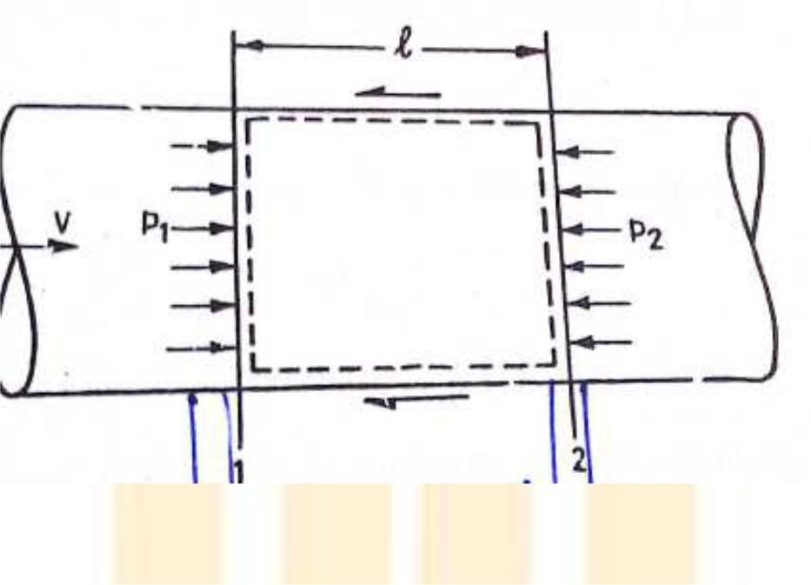

Figure: Losses in pipes during flow

Friction factor in pipes or Major losses:- A pipe is a closed conduit through which fluid flows under the pressure. When in the pipe, fluid flows, some of potential energy is lost to overcome hydraulic resistance which is classified as:-

- The viscous friction effect associated with fluid flow.

- The local resistance which result from flow disturbances caused by Sudden expansion and contraction in pipe
Obstruction in the form of valves, elbows and other pipe fittings.
Curves and bend in the pipe.
Entrance and exit losses.
The viscous friction loss or major loss in head potential energy due to friction is given by h_{f}.
Hence the major head loss is friction loss-
h_{f} = 4fLV²/2dg.
Where,
hf =Major head loss
L= Length of pipe
4f = Friction factor
V = Inlet velocity
g = Acceleration due to gravity
d = Diameter of pipe
Procedure:-

- Note down the relevant dimensions as diameter and length of pipe between the pressure tapping, area of collecting tank etc.

- Pressure tapping of a pipe is kept open while for other pipe is closed.

- The flow rate was adjusted to its maximum value. By maintaining suitable amount of steady flow in the pipe.

- The discharge flowing in the circuit is recorded together with the water level in the left and right limbs of manometer tube.

- The flow rate is reduced in stages by means of flow control valve and the discharge & reading of manometer are recorded.

- This procedure is repeated by closing the pressure tapping of this pipe, together with other pipes and for opening of another pipe.

Observation:-

Diameter of pipe D =

Length of pipe between pressure tapping L =

Area of collecting tank =

Sr. | Manometer Reading |  |  |  |  | Discharge measurement |  |  |  | ,
-
. 08/
ℎ₍
No. | Left | Right | Difference |  |  | Initial | Final | Time | Discharge
 | limb | limb | of head |  | in | cm. | cm. | sec | Q
 | H₁ | H₂ | terms |  | of |  |  |  | (cm³/sec)
 |  |  | water | h_{f} | =
 |  |  | 13.6 | (H₂-
 |  |  | H₁)

Result:-
Precautions:-

- When fluid is flowing, there is a fluctuation in the height of piezometer tubes, note the mean position carefully.

- There in some water in collecting tank.

- Carefully keep some level of fluid in inlet and outlet supply tank.

EXPERIMENT NO.: 08
Objective:-
To determine the head loss for a sudden enlargement.

Apparatus Used:-
A flow circuit of G. I. pipes of different pipe fittings Sudden enlargement from 25 mm dia to 50 mm dia, U-tube differential manometer, collecting tank.
Principle:-
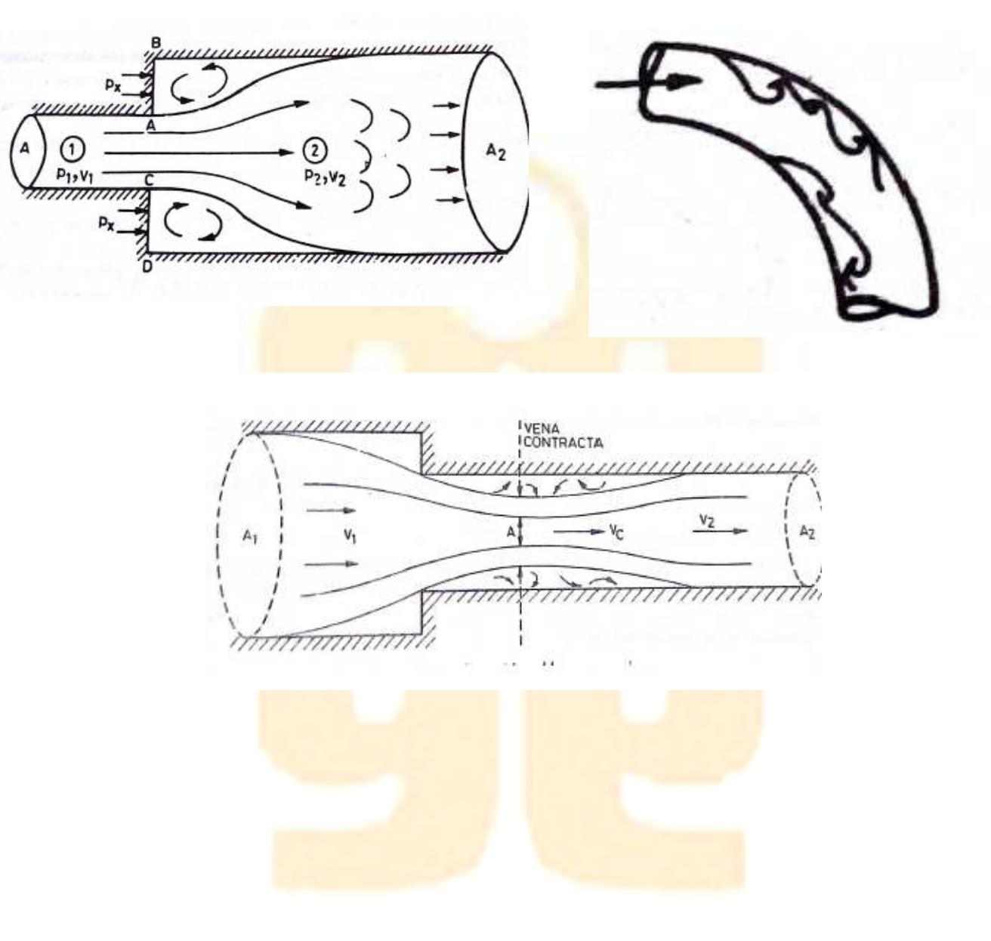

The local or minor head losses are caused by certain local features or disturbances. The disturbances may be caused in the size or shape of the pipe. This deformation affects the velocity distribution and may result in eddy formation.
Sudden Enlargement:- Two pipe of cross-sectional area A1 and A2 flanged together with a constant velocity fluid flowing from smaller diameter pipe. This flow breaks away from edges of narrow edges section, eddies from and resulting turbulence cause dissipation of energy. The initiations and onset of disturbances in turbulence is due to fluid momentum and its area. It is given by:-
h exit =V2/2g
Eddy loss:- Because the expansion loss is expended exclusively on eddy formation and continues substance of rotational motion of fluid masses.
Procedure:-

- Note down the relevant dimensions as diameter and length of pipe between the pressure tapping, area of collecting tank etc.

- Pressure tapping of a pipe a is kept open while for other pipe is closed.

- The flow rate was adjusted to its maximum value. By maintaining suitable amount of steady flow in the pipe.

- The discharge flowing in the circuit is recorded together with the water level in the left and right limbs of manometer tube.

- The flow rate is reduced in stages by means of flow control valve and the discharge & reading of manometer are recorded.

- This procedure is repeated by closing the pressure tapping of this pipe, together with other pipes and for opening of another pipe.

Observation:-
Diameter of pipe D =
Length of pipe between pressure tapping L =
Area of collecting tank =
Types of the fitting =

Sr. |  |  | Manometer reading |  |  |  | Discharge measurement |  |  |  | Coefficient
No. |  |  |  |  |  |  |  |  |  |  | of loss K=
 |  |  |  |  |  |  |  |  |  |  | 2g/V².h_{L}
 | Left | limb | Right | Difference | of | Initial |  | final | time | Discharge
 | h1 |  | limb h2 | head in terms | of
 |  |  |  | water h_{f} = 13.6
 |  |  |  | (h2-h1)
1
2
3
Result:-
Precautions:-

- When fluid is flowing, there is a fluctuation in the height of piezometer tubes, note the mean position carefully.

- There in some water in collecting tank.

- Carefully keep some level of fluid in inlet and outlet supply tank.

EXPERIMENT NO.: 09
Objective:-
To determine the head loss for a sudden Contraction.

Apparatus Used:-
A flow circuit of G. I. pipes of different pipe fittings Sudden contraction from 50 mm dia to 25 mm dia, U-tube differential manometer, collecting tank.
Principle:-

The local or minor head losses are caused by certain local features or disturbances. The disturbances may be caused in the size or shape of the pipe. This deformation affects the velocity distribution and may result in eddy formation.

Sudden Contraction:- It represents a pipe line in which abrupt contraction occurs.
Inspection of the flow pattern reveals that it exists in two phases.
hcon = (Vc – V2) /2g
Vc = velocity at vena contracta
Eddy loss:- Because the expansion loss is expended exclusively on eddy formation and continues substance of rotational motion of fluid masses.

Procedure:-

- Note down the relevant dimensions as diameter and length of pipe between the pressure tapping, area of collecting tank etc.

- Pressure tapping of a pipe a is kept open while for other pipe is closed.

- The flow rate was adjusted to its maximum value. By maintaining suitable amount of steady flow in the pipe.

- The discharge flowing in the circuit is recorded together with the water level in the left and right limbs of manometer tube.

- The flow rate is reduced in stages by means of flow control valve and the discharge & reading of manometer are recorded.

- This procedure is repeated by closing the pressure tapping of this pipe, together with other pipes and for opening of another pipe.

Observation:-
Diameter of pipe D =
Length of pipe between pressure tapping L =
Area of collecting tank =
Types of the fitting =
Sr. |  |  | Manometer reading |  |  |  | Discharge measurement |  |  |  | Coefficient
No. |  |  |  |  |  |  |  |  |  |  | of loss K=
 |  |  |  |  |  |  |  |  |  |  | 2g/V².h_{L}
 | Left | limb | Right | Difference | of | Initial |  | final | time | Discharge
 | h1 |  | limb h2 | head in terms | of
 |  |  |  | water h_{f} = 13.6
 |  |  |  | (h2-h1)
1
2
3
Result:-
Precautions:-

- When fluid is flowing, there is a fluctuation in the height of piezometer tubes, note the mean position carefully.

- There in some water in collecting tank.

- Carefully keep some level of fluid in inlet and outlet supply tank.

EXPERIMENT NO.: 10
Objective:-
To determine the coefficient of discharge of an orifice of a given shape. Also to determine the coefficient of velocity and the coefficient of contraction of the orifice mouth piece.
Apparatus Used:-
A flow circuit of G. I. pipes of different pipe fittings Sudden contraction from 50 mm dia to 25 mm dia, U-tube differential manometer, collecting tank.

Principle:-

While installing a pipeline for conveying a fluid, it is generally not possible to install a long pipeline of same size all over for various reasons, like space restrictions, aesthetics, location of outlet, etc hence, the pipe size varies and it changes its direction. Also, various fittings are required to be used. All these variations of sizes and the fittings cause the loss of fluid head.
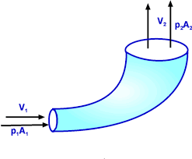
Losses at bends,
The flow pattern regarding separation and eddying in region of separations in bends, valves. The resulting head loss due to energy dissipation can be prescribed by the relation h = KV2/2g. Where V is the average flow velocity and the resistance coefficient K dependson parameter defining the geometry of the section and flow. Resistances of large sizes elbows can be reduced appreciably by splitting the flow into a number of streams by a jet of guide vanes called cascades.

Procedure:-
- Note down the relevant dimensions as diameter and length of pipe between the pressure tapping, area of collecting tank etc.

- Pressure tapping of a pipe a is kept open while for other pipe is closed.

- The flow rate was adjusted to its maximum value. By maintaining suitable amount of steady flow in the pipe.

- The discharge flowing in the circuit is recorded together with the water level in the left and right limbs of manometer tube.

- The flow rate is reduced in stages by means of flow control valve and the discharge & reading of manometer are recorded.

- This procedure is repeated by closing the pressure tapping of this pipe, together with other pipes and for opening of another pipe.

Observation:-
Diameter of pipe D =
Length of pipe between pressure tapping L =
Area of collecting tank =
Types of the fitting =
Sr. |  |  | Manometer reading |  |  |  | Discharge measurement |  |  |  | Coefficient
No. |  |  |  |  |  |  |  |  |  |  | of loss K=
 |  |  |  |  |  |  |  |  |  |  | 2g/V².h_{L}
 | Left | limb | Right | Difference | of | Initial |  | final | time | Discharge
 | h1 |  | limb h2 | head in terms | of
 |  |  |  | water h_{f} = 13.6
 |  |  |  | (h2-h1)
1
2
3

RESULT:-
Precautions:-

- When fluid is flowing, there is a fluctuation in the height of piezometer tubes, note the mean position carefully.

- There in some water in collecting tank.

- Carefully keep some level of fluid in inlet and outlet supply tank.

