INDEX

LIST OF EXPERIMENTS
S. No. | Practical | Page No.
1 | Demonstration and working on Electronic Total Station, Measurement of distances, horizontal and vertical angles and coordinates. | 2
2 | Measurement of area of a land parcel using Total station. | 3-4
3 | To layout a precise traverse in a given area and to compute the adjusted coordinates of survey stations. | 5
4 | Demonstration and working pocket stereoscope/ Mirror Stereoscopes, Parallax bar and Aerial photographs | 6-7
5 | Visual interpretation of standard false colour composite(FCC).. | 8-9
6 | Digitization of physical features on a map/image using GIS software. | 10
7 | Coordinates measurement using GPS | 11-12

EXPERIMENT NO:-1
Objective: Demonstration and working on Electronic Total Station, Measurement of distances, horizontal and vertical angles and coordinates.
General: Total station is a combination of Electronic Theodolite and Electronic Distance Meter (EDM) in one unit. This instrument directly measures 3D co-ordinates, horizontal and vertical distances. This has large internal memory of 3000 points to store field data and can be directly down loaded to the computer from the instrument through interface cable.
Principle of EDM: The basic principle is the indirect determination of the time required for a light beam to travel to between two stations and by using frequency the distance is displayed.
Procedure:
Engineers are constantly faced with slopes or sloped surfaces for roads, canals, dam sites, building sites, water and sewer pipe networks, and many other construction projects. Most field measurement techniques measure the slope distance or straight line between two points. For engineering design or Lab #2 8 HD SD v z z construction layouts, the horizontal and vertical distances must be computed. Understanding slope measurements and the corresponding horizontal and vertical relationships is very important. There are many ways in which these distances can be measured and calculated. Slope distances can be measured by taping, pacing, or using a Total Station. The angle of the slope can be measured as a vertical angle, zenith angle, or percent grade. The following equations summarize how horizontal and vertical distances can be computed from a slope distance and these angle measurements.
HD = SD * (cos(v))
HD = SD * (sin(z))
HD = SD * (cos (arctan (g)))
VD = SD * (sin (v))
VD = SD * (cos (z))
VD = SD * (sin(arctan(g)))
Basic Functions of EDM:-
- It generates the carrier and measuring wave frequencies.
- It modulates and demodulates the carrier wave.
- It measures the phase difference between the transmitted received waves.
- It displays the results result of measurement.
Conclusion: Thus the study about the Total station is practiced.

EXPERIMENT No. - 02
Objective:-Measurement of area of a land parcel using Total station.
Equipments: Total station, Plumb bob, Tripod etc.
Method: This program calculates the area of a closed figure from measured data. Press the MENU key and P↓ [F4] to get to the PROGRAMS [F1] option. Press P↓ [F4] to get to the AREA [F1] option. We will use the MEASUREMENT option, therefore press YES [F2].We also will not be using the grid factor, so press DON’T USE [F2].Sight the prism on the first point and press the MEAS [F1] key, move the prism to the next point and re-sight on the prism and press the MEAS [F1] key again, continue sighting and measuring to all points. When 3 or more points are measured, the area surrounded by the points is calculated and the result will be shown. Be sure you are in the units that you want. This can be changed by pushing the UNITS key and selecting those you want.
Procedures:
1. Stake out an area on the Quad with five sides with tilted stakes. Tilting the stakes allow the tip of the rod be directly at the desired point, which is the intersection of the pin and the ground. When the Total Station is placed over that point, laser plummets onto the same pin-ground intersection. Each side of the traverse should be greater than 100 feet long.
2. Start your traverse on one corner of the area you just staked out and orient your total station to north. Note: If you need instructions on how to orient to north look at the instructions at the end of this lab.
3. Find the true azimuth angle to your first leg. Follow the same procedures of inverting and repeating as outlined in Lab 4. Because this azimuth angle will affect the rest of your traverse you should do at least a 1D measurement.
4. Each person will set up and run the instrument for at least one point of the traverse. Measure the horizontal angle and distance between the two adjacent points. Make sure you measure the HD, not SD, because you cannot assume the ground is level. Note: You will set up over each point of the traverse.
5. Each horizontal angle should be measured using one set, inverting and repeating (as described in Lab 4) each measurement. Measure the angle by turning between the pins, not the prisms, to avoid excessive error. Record the average of the angles (hm).Each person should measure at least one angle set.
6. Determine the horizontal distances at least once for each direction. If measured more than once, average those values measured for each leg of the traverse to get the actual measurement.
7. Use the Area program on the Total Station to determine the area of the traverse. Remember the Total Station needs to be in a position to see all the vertices of the polygon, but not be on them. This can be either inside or outside the polygon or along one of the sides of the polygon.
8. Balance the angles as outlined in the lab. For this lab, if the sum of the, go back and re-survey. Interior angles is off by more than 1
9. Use the balanced angles to find bearings for each segment of the traverse. Going clockwise, use bearings and the horizontal distances to calculate X and Y coordinates for each point. You will calculate the bearing to the first leg from the true azimuth reading from Step 2 and then go around the traverse from there to find the other bearings.
10. Using your new data for point number one, calculate the closure error, and compute the precision of your survey.

11. Using the Compass Rule Adjustment, adjust the coordinates for each point. You will use the coordinates assigned to the first point of your traverse. See the map for point locations and coordinate values.
12. Calculate the area within the closed traverse.
Result: - The calculated area is…………………

EXPERIMENT NO.: 3

Objective.: To layout a precise traverse in a given area and to compute the adjusted coordinates of survey stations.

Equipments:
- Total Station and tripod
- Prism and prism rod
- Pins
- Arc Map

Procedure:
Traverse Coordinates
There are both open and closed traverses; in this lab we will be performing a open traverse. A traverse is used to determine the exact location of an unknown point. By knowing a bearing angle and a distance from a known point, the X (also called easting, or departure) and Y (also called northing, or latitude) from the known point can be calculated. The rectangular coordinates of the new point can then be determined with respect to the known point. If the known point already has coordinates, the X and Y are added algebraically to these coordinates. This procedure is followed around the traverse and the coordinates for each new point are determined.
For this lab you will be given points with known x and y coordinates (northing and easting, latitude and departure). The coordinates are based on the State Plane NAD 83 Utah Central projection which covers all of central Utah. As you work through the lab keep in mind that these coordinates are measured in feet. This is very important when you input these coordinates back into Arc Map to create your plot because you could be off by a factor of three+ in your results. The map at the end of this lab shows six control points. Using your given point and another point (or azimuth angle) you will orient north, which will assist you by giving true bearings and azimuth angles for the sides of your traverse. You will then be able to compute the correct coordinates to input into Arc Map so the representation of your area will be accurate.
Observations:
Either azimuth or bearing angles may be used, along with a horizontal distance to compute X and Y:
Azimuth Angles
X = D * sin A
Y = D * cos A
Conclusion:

EXPERIMENT NO.: 4
Object: Demonstration and working pocket stereoscope/ Mirror Stereoscopes, Parallax bar and Aerial photographs.
Instruments: Pocket stereoscope/ Mirror stereoscope, and a pair of aerial photograph.
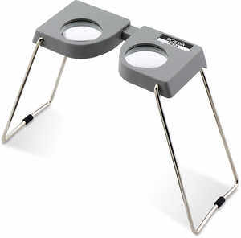

Principle: The pocket stereoscope sometimes known as a lens stereoscope, consists of two magnifying lenses mounted in a metal frame. Because its simplicity and ease of carrying. It is the type used most frequently by military personnel.
Procedure: - A method to orient a pair of aerial photographs for best three dimensional viewing is outlined below:
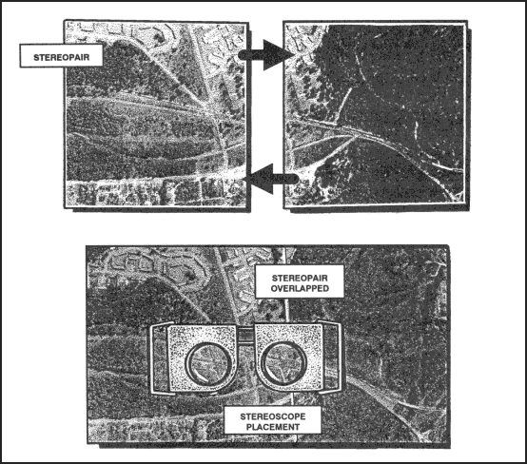
- Arrange the selected pair of photos in such a way that the shadows on them generally appear to fall toward the viewer. It is also desirable that the light source enters the side away from the observer during the study of the photographs
- Place the pair of photographs on a flat surface so that detail on one photograph is directly over the same detail on the other photograph.

- Place the stereoscope over the photographs so that left lens is over the left photograph and the right lens is over the right photograph.

- Separate the photographs along the line of flight until a piece of detail appearing in the overlap area of the left photograph is directly under the left lens and the same piece of detail on the right photo is directly under the right lens.
- With the photograph and stereoscope in this position, a three-dimensional image should be seen. A few minor adjustments may be necessary, such as adjusting the aerial photographs of the stereoscope to obtain the correct position impression of being in an aircraft looking down at the ground.
- The identification of features on photographs is much easier and more accurate with this three-dimensional view. The same five factors of recognition (size, shape, shadow, tone, and surrounding objects) must still be applied, but now, with the addition of relief, a more natural is seen.

EXPERIMENT NO.: 5
Objective.: Visual interpretation of standard false colour composite(FCC).
Introduction: The display colour assignment for any band can be done in an entirely arbitrary manner. In this case, the colour of a target in the displayed image does not have any resemblance to its actual colour. The resulting product is known as a false colour composite image. There are many possible schemes of producing false colour composite images. However, some scheme may be more suitable for detecting certain objects in the image.
It is very common false colour composite scheme for displaying a SPOT multispectral image is known below:
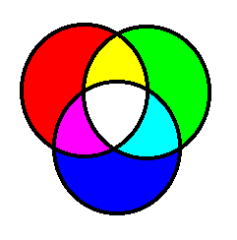
R=XS3 (NIR band)
G=XS2 (Red band)
B=XS1 (green band)

This false colour composite scheme allows vegetation to be detected readily in the image. In this type of false colour composite images, vegetation appears in different shades of red depending on the types and conditions of the vegetation, since it has a high reflectance in the NIR band (as shown in the graph).
Clear water appears dark-bluish (higher green band reflectance), white turbid water appears cyan (higher red reflectance due to sediments) compared to clear water. Bare soils, roads and buildings may appear in various shades of blue, yellow or grey, depending on their composition.
Four main types of information contained in an optical image are often utilized for image interpretation.

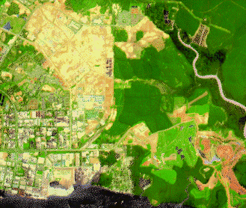

The companion photo below is a notably different colour version (typical false colour rendition) in which verious kinds of vegetation display in several tones of red, pink or yellow (the latter two may indicate a degree of stressed or unhealthy vergetation).
This type of projected color combination, yielding the false colour IR composite, is ordinarily used to emphasize a property of healthy vergetation in which incident light in map.

EXPERIMENT No.:6
Objective : Digitization of physical features on a map/image using GIS software.
Equipment: GIS.
Theory: GIS practitioners may be geographers survey planners or computer engineers. Despite the diversity in approaches GIS has a special set and knowledge needs by the professional to use.
GIS in all its forms and implementation GIS may be define as computer based information system witch attempts to store, manipulate analysis and display spatially referenced and associated attribute data for solving complex research planning and management problem. The objectives of collecting item in to useful information by means of a GIS transcend the traditional boundary of data processing and information should include not only the data processing. Functions of these systems but allow their analytical capabilities for deriving spatial knowledge and intelligence as well.
Conclusion:
- To support decision matching based on (data) spatial data.
- To support general reason.
- To collect manipulated and use spatial data in data base management.

EXPERIMENT NO.: 7
Objective: Coordinates measurement using GPS
Introduction- Portable GPS Units were bulky with universal frames and capabilities however, as technology has advanced in other areas, GPS technology has benefited, as well, Now, you can purchase incredibly high-tech Portable GPS Units with any of a number of features, Some of the features you can choose from include.
Features: Voice Direction, Touch Screen Display, High Sensitivity GPS receivers, WAAS Technology Anti-Glare Screen Display, Customizable Screen Icons, Bluetooth Capabilities Software Add-ons (travel guides), MP3 player Functionality, Preloaded Maps, Anti-theft features.
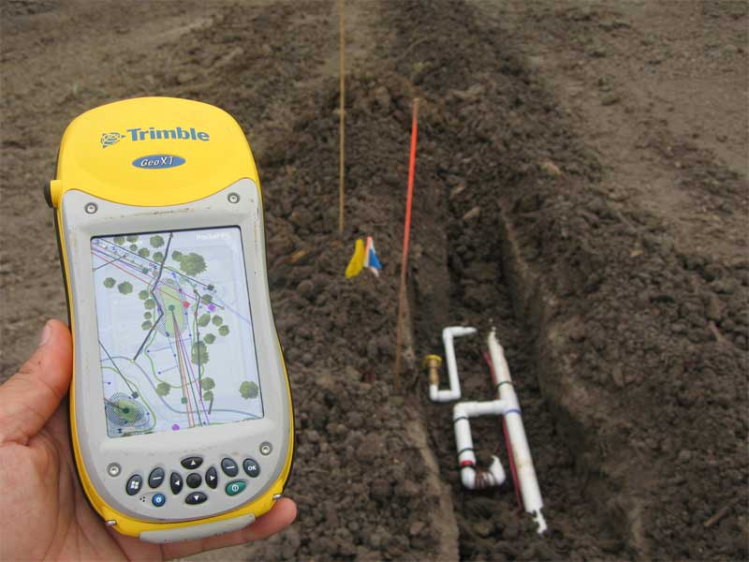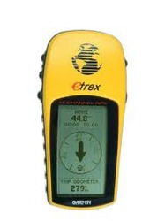
Theory- Portable GPS Units specifically, are used such as road and land surveyors. The surveyors can use the units to plan roads, map areas, find markers, plot boundaries, and discover borders along land locations (in terms of distance) easily. Of course, getting to the location initially is also quite easy thanks to the capabilities of these portable GPS Units.
The nice thing about many of these units is the ability to save and store data. Since portable GPS units can be hooked into laptops and PDAs, data from your GPS can be sent to your PDA and surveyors. As land and roads are being plotted, maps specifically generated from a certain location can be sent to a laptop to assist in the process.
The current GPS consists of three major segments. These are the space segment(SS), a control segment(CS), and a user segment(US). The U.S. Air Force develops, maintains, and operates the space and control segment GPS satellites from space, and each GPS receiver uses these signals to calculate its three dimensional location (latitude, longitude, and altitude) and the current time, The space segment is composed of the 24 to 32 satellites and also includes the payload adapters the boosters required to launch them into orbit. The control segment is composed of a master control station, an alternate master control station, and a host of dedicated and shared and monitor stations.

While originally a military project, GPS is considered a dual-use technology, meaning it has significant military and civilian applications.

Application of GPS:
- The accuracy of GPS time signals is second only to the atomic clocks upon which they are based.
- Applying location coordinates to digital objects such as photographs and other document for purpose such as creating map overlays.
- Location determines what content to display, for instance, information about and approaching point of interest.
- Both civilian and military cartographers use GPS extensively.
- Navigators value digitally precise velocity and orientation measurement.
- GPS enable highly accurate time stamping of power system measurements, making it possible to compute.
- The use of GPS technology to identify, locate and maintain contact reports with one or more vehicles in real-time.

