INDEX

S.R. NO | NAME OF  EXPERIMENT | Date of performance | Experiment marks | Teacher’s signature
1. | To determine the Manning’s coefficient of roughness ‘n’ for the bed of a given flume.
2. | To calibrate a broad-crested weir.
3. | To study characteristics Francis Turbine.
4. | To study characteristics of Kaplan Turbine.
5. | To determine coefficient of discharge for given rectangular notch.
6. | To study the characteristics of free hydraulic jump.
7. | To conduct a test on Pelton Wheel Turbine at a Constant Head.
8. | To determine the overall efficiency of a Centrifugal Pump.
9. | To study the flow characteristics over a hump placed in an open channel.
10. | To study the flow through a horizontal contraction in a rectangular channel.

EXPERIMENT NO: 01

AIM: To determine the Manning’s coefficient of roughness ‘n’ for the bed of a given flume.

EXPERIMENTAL SETUP:

For conducting this experiment long hollow rectangular channel is used with bed slope adjustments, point gauge is kept on upstream side of channel to measure the depth of water. Inlet pipe is provided with flow regulating arrangement. Outlet of channel is directly taken to the measuring tank which is provided with piezometer tube arrangement outlet is provided with measuring tank.

THEORY:

In open channel water flows under atmospheric pressure, when water flows in an open channel, resistance is offered to it, which causes loss of energy. A uniform flow will be developed if the resistance is balanced by the gravity forces. The magnitude of the resistance when other physical factors of the channel are kept unchanged depends on the velocity of the flow. The following formulae are used to measure the velocity are :
Manning’s formula is V= (1/N)*R^{2/3}S_{O}^{1/2}

Where N is manning’s roughness coefficient

R is hydraulic mean radius
S_{o} is channel bottom slope

The relation between chezy and manning’s formula is

C = (1/N)R^{1/6}

PROCEDURE:
- Remove all the obstructions in the channel

- Prepare the unit for open channel experiment by lifting both the gates so that there is no obstruction to the flow of water.

- By screwing up the wheel of the tilting arrangement the required slope for the channel can be attained. Note the readings in the vertical scale as shown.

- Allow the water in the channel, so that the water flows along the open channel at the steady condition.

- With the help of the point gauge, find the head of water in the channel. Let it be y=__________ m

- Take manometer reading L.

- Calculate the discharge by using formula,

Q_{act} = Cd.a √ (2gh).

8. Repeat Steps 1 to 6 for different readings. i.e. head of water and for different channel slope.

OBSERVATIONS:

- Width of channel “ B ”= 30 cm

- Diameter of orifice “d”= 4.8 cm

- Area of orifice “a” = 18.09 cm²

3. Length of channel= 6 m = 6000 mm

OBSERVATION TABLE:

S.NO | BED | C.B. | W.S | DIFF. | Manometer | h | Qact | Hydraulic | V=Q/a | C | 1/N | N
 | SLOPE(So) |  |  | “Y” | Reading |  |  | Depth
 |  |  |  | (cm) | “ h’ ” |  |  | “R”
1 | 5/6000
2 | 10/6000
3 | 15/6000
4 | 20/6000
5 | 25/6000
6 | 30/6000

SAMPLE CALCULATIONS:

- Y = W.S. - C.B

- h = h’ *(13.6-1)

- Q_{act} = Cd.a √(2gh)

Where Cd= 0.611; g= 981 cm/s²

- R= Area / Wetted Perimeter = B*Y/ B+2Y

- Velocity = Qact/Area

- V=C √(RS_{o})
- V= (1/N)*R^{2/3}S_{O}^{1/2}

RESULTS:

- Average value of manning’s constant =N=_______

EXPERIMENT NO.: 02

Objective:
To calibrate a broad-crested weir.

Apparatus Used:-

A channel or flume to provide a flow passage, A broad crested weir, Hook-gauge to measure the head over the crest over the crest of weir, stop watch.

Principle:-
A weir is an opening in the side walls of a tank. It is same as an orifice without having an outer boundary. If the head is reduced the liquid flows with its level below the top of the orifice. The wall above the liquid level is superfluous and can be removal.

The difference between a large orifice and weir is that liquid flows through the orifice while it flows over the weir. The flow of liquid coming out of orifice is called jet while that comes through the weir is called ‘nape, sheet or vein’.
The relation between H and h for maximum discharge is, h = 23 H Theoretical discharge, Qt = 1.705 L H32 in m3/sec
Where,
L = Length of the weir measured parallel to width of channel in meters

H = Constant head over the crest on the upstream of channel in meters.

H = (h2-h1).

Actual discharge,Qa = Internal plan area of collecting tank x rise in collecting tank/ time of collection (t) in m3/sec.

Procedure:-
- Open the control valve and allow the water level to rise up to the skill level of the weir.

- Adjust the tip of the hook gauge such that it coincides with water surface and note the reading on hook gauge scale as h1on u/s.
- Note the time required for known rise of water level.

- Keeping the length and width of the collecting tank as default values repeat the experiment by adjusting flow of water and hook gauge.

Observation1:

- Open the control valve and allow the water level to rise up to the skill level of the weir.

- Adjust the tip of the hook gauge such that it coincides with water surface and note the reading on hook gauge scale as h1on u/s.

Observation2:

- Operate the control valve such that water flows over the weir to some height.

- Again adjust the tip of the hook gauge such that it coincides with water surface and note the water level by means of hook gauge as h2.

Observation3:

- Note the time required for known rise of water level.

- Keeping the length and width of the collecting tank as default values repeat the experiment by adjusting flow of water and hook gauge.

Result:
Average coefficient of discharge of a broad crested weir.
EXPERIMENT NO.: 03

Objective:-
To study characteristics Francis Turbine.

Apparatus Used:-
Francis Turbine Test Rig, stop watch, tachometer.

Principle:-
. All the energy is transferred by means of Nozzle & Spear arrangement. The water leaves the nozzle in a jet formation. The jet of water then strikes on the buckets of Pelton Wheel Runner. The buckets are in the shape of double cups joined together at the middle portion.
FORMULAE
VENTURIMETER READING
h = (p1 - p2) x 10 (m)

Where

p1, p2 - venturimeter readings in kg / cm2

DISCHARGE

Q = 0.011 x √h (m3 / s)

BRAKE HORSEPOWER
BHP = ( x D x N x T) / (60 x 75) (h p)

Where

N = Speed of turbine in (rpm)

D = Effective diameter of brake drum = 0.315m

T = torsion in [kg]

INDICATED HORSEPOWER
HP = 1000 x Q x H / 75 (hp)

Where

H – Total head in (m)
PERCENTAGE EFFICIENCY
% = B.H.P x 100 / I.H.P ( %)

GRAPHS
The following graphs are drawn

- BHP (vs.) IHP

- BHP (vs.) speed

- BHP (vs.) % efficiency

TABULATION

 | Pressure | Pressure |  |  | Weight | Spring
 | (H) |  | Orifice meter |  |  |  | Net
Sl. |  | Gauge |  | Discharge | on | balance |  | Speed
 | gauge |  | Head |  |  |  | load
 |  | Reading |  |  | hanger | reading
No | reading
 | P.S | P1 P2 P | h | Q | W1 | W2 | W | N
 | kg/cm2 | Kg/cm2 |  | m3/sec | Kg | kg | kg | rpm
1
2
3
4
5
6

FRANCIS TUBRINE TEST RIG 1 kW, 1000 RPM (CLOSED CIRCUIT) DETAILS
Brake drum dia D = 0.2m

Rope Dia t = 0.015m

Effective radius of = (D/2 + t)

Brake drum Re = 0.115m

Weight of rope & hanger = 1kg

Guide vane opening =0.5

“K” value : 9.11 x 10-310-3

Input total head H in m of water = Pressure gauge reading in kg/cm2x 10

Orificemeter Head h in m of water h= (p1-p2) x 10m of water

Discharge Q = K√h (h in m of water)

Input power IP=γ x H x Q kW (H in m of water)

Brake Drum net load W = (W1 + weight of rope & hanger) – W2 kg Turbine output OP = (2π NWRe x 9.81)/ 60000 kW

Efficiency η = (output / input) x 100%

PUMP MODEL: CRI; LH3

Procedure:-
- The Francis turbine is started

- All the weights in the hanger are removed

- The pressure gauge reading is noted down and this is to be Maintained constant for different loads

- Pressure gauge reading is ascended down

- The venturimeter reading and speed of turbine are noted down

- The experiment is repeated for different loads and the reading are tabulated.

Result:- Thus the performance charactertics of the Francis wheel turbine are done and the maximum efficiency of the turbine is …………. %

Safety Precautions:-
- Water flow should be steady and uniform.
- The reading on the scale should be taken without any error.
- The weight should be put slowly & one by one.
- After changing the vane the flask should be closed tightly.

EXPERIMENT NO.: 04

Objective:-
To study characteristics of Kaplan Turbine.

Apparatus Used:-

Kaplan Turbine, Supply Pump, Orifice meter, Pressure & Vacuum Gauge, Sump tank,Piping System.
Principle:-
The Kaplan turbine is a propeller-type water turbine which has adjustable blades. It was developed in 1913 by Austrian professor Viktor Kaplan, who combined automatically adjusted propeller blades with automatically adjusted wicket gates to achieve efficiency over a wide range of flow and water level.
The Kaplan turbine was an evolution of the Francis turbine. Its invention allowed efficient power production in low-head applications which was not possible with Francis turbines. The head ranges from 10–70 metres and the output ranges from 5 to 200 MW. Runner diameters are between 2 and 11 metres. Turbines rotate at a constant rate, which varies from facility to facility. That rate ranges from as low as 54.5 rpm (Albeni Falls Dam) to 429 rpm. The Kaplan turbine installation believed to generate the most power from its nominal head of 34.65 m is as of 2013 the Tocoma Dam Power Plant (Venezuela) Kaplan turbine generating 230 MW (Turbine capacity, 257 MVA for generator) with each of ten 8.6 m diameter runners.
FORMULAE:-

Input Power = γ QH in kW

Where

- = Specific weight of water = 9.81 kN/m3 Q = Discharge in m3/sec.

H = Supply head in meters.

Brake Power = 2π NT x 9.81/ 60000 kW Efficiency = Output/ Input *100%
Where

N = Turbine speed in RPM.

T = Torque in kgm, (effective radius of the brake in meters (R)x The net brake load in kg (W).

Re = 0.165m

GRAPHS

The following graphs are drawn.

- BHP Vs IHP

- BHP Vs speed

- BHP Vs Efficiency

KAPLAN TUBRINE TEST RIG 1 kW, 1000 RPM (CLOSED CIRCUIT)

DETAILS

Brake drum dia D = 0.3m

Input total head H in m of water = Pressure gauge reading in kg/cm2x 10 Orificemeter Head p in m of water h= (p1-p2) x 10

Discharge Q = K√p (h in m of water)

Input power IP=γ x H x Q kW (H in m of water)

Brake Drum net load W = (W1 + weight of rope & hanger) – W2 kg Turbine output OP = (2π NWRe x 9.81)/ 60000 kW

Efficiency η = (output / input) x 100%

Rope Dia t = 0.015m

Effective radius of = (D/2 + t) = 0.165m

Weight of rope & hanger = 1kg

Guide vane opening =0.8

Run away speed = 1750RPM

“K” value = 2.3652 x 10-2

Pumpset Brand & Model = CRI;1

 | Pressure | Pressure | Orifice |  | Weight | Spring
 | (H) |  |  |  |  |  | Net
 |  | Gauge | meter | Discharge | on | balance |  | Speed | output | Input | Eff.
Sl. | gauge |  |  |  |  |  | load
 |  | Reading | Head |  | hanger | reading
 | reading
No
 | P.S | P1 P2 P | h | Q | W1 | W2 | W | N
 | kg/cm2 | Kg/cm2 |  | m3/sec | Kg | kg | kg | rpm | OP | IP | η
 |  |  |  |  |  |  |  |  | kW | kW | %

1

2

3

4

5

6

Procedure:-
- Keep the runner vane at require opening
- Keep the guide vanes at required opening
- Prime the pump if necessary
- Close the main sluice valve and them start the pump.
- Open the sluice valve for the required discharge when the pump motor switches from star to delta mode.
- Load the turbine by adding weights in the weight hanger. Open the brake drum cooling water gate valve for cooling the brake drum.
- Measure the turbine rpm with tachometer
- Note the pressure gauge and vaccum gauge readings
- Note the orifice meter pressure readings.
RESULT:-
Thus the performance characteristic of the Kaplan Turbine is done and the maximum
efficiency of the turbine is ………. %

EXPERIMENT NO.: 05

Objective:-
To determine coefficient of discharge for given rectangular notch.

Apparatus Used:-

Hydraulic bench, Notches, Rectangular, Hook and point gauge, Calibrated collecting tank, Stop watch
Principle:-
In open channel hydraulics, weirs are commonly used to either regulate or to measure the volumetric flow rate. They are of particular use in large scale situations such as irrigation schemes, canals and rivers. For small scale applications, weirs are often referred to as notches and invariably are sharp edged and manufactured from thin plate material. Water enters the stilling baffles which calms the flow. Then, the flow passes into the channel and flows over a sharp-edged notch set at the other end of the channel. Water comes of the channel in the form of a nappe is then directed into the calibrated collection tank. The volumetric flow rate is measured by recording the time taken to collect a known volume of water in the tank.A vertical hook and point gauge,mounted over the channel is used to measure the head of the flow above the crest.
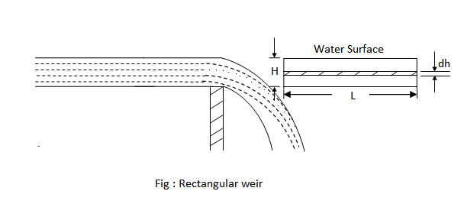

Procedure:-
- Keep the runner vane at require opening
- Keep the guide vanes at required opening
- Prime the pump if necessary
- Close the main sluice valve and them start the pump.
- Open the sluice valve for the required discharge when the pump motor switches from star to delta mode.
- Load the turbine by adding weights in the weight hanger. Open the brake drum cooling water gate valve for cooling the brake drum.
- Measure the turbine rpm with tachometer.

OBSERVATION:
breadth of the rectangular notch =
Area of collecting tank(A)=
Result:-

EXPERIMENT NO:6

AIM- To study the characteristics of free hydraulic jump.

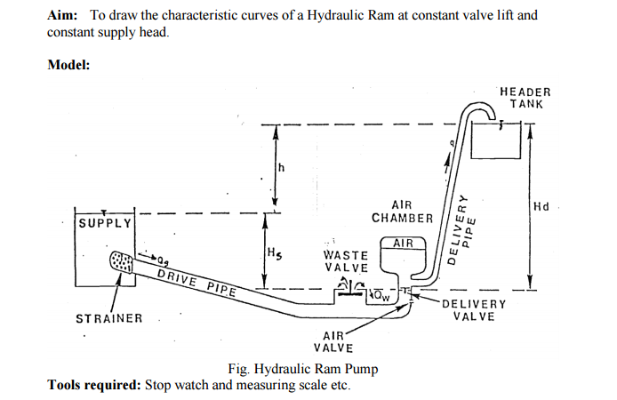

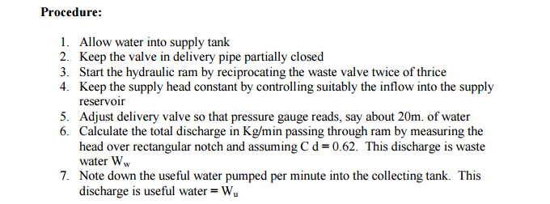

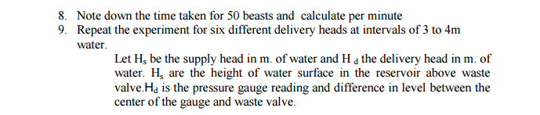

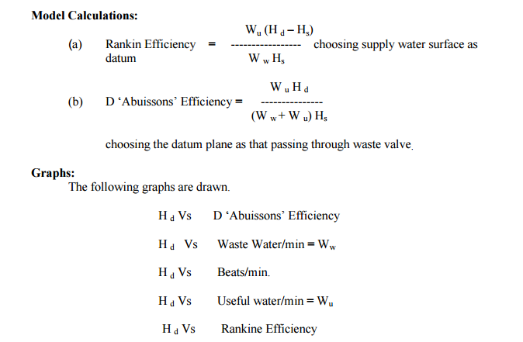

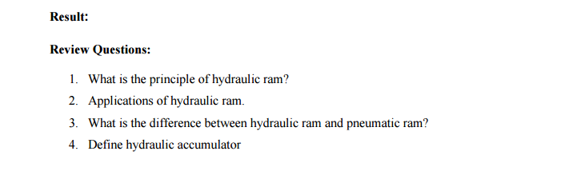

EXPERIMENT NO:7

AIM: To conduct a test on Pelton Wheel Turbine at a Constant Head.

APPARATUS:

- Pelton Wheel Turbine

- Nozzle & Spear Arrangement

- Pressure Gauges (03 Nos. – Range = 00 – 07 kg/cm²)

THEORY:

Pelton Wheel Turbine is an IMPULSE type of turbine which is used to utilize high head for generation of electricity. All the energy is transferred by means of Nozzle & Spear arrangement. The water leaves the nozzle in a jet formation. The jet of water then strikes on the buckets of Pelton Wheel Runner. The buckets are in the shape of double cups joined together at the middle portion. The jet strikes the knife edge of the bucket with least resistance and shock. Then the jet glides along the path of the cup & jet is deflected through more than 160 – 170 degrees. While passing through along the buckets, the velocity of water is reduced & hence impulse force is applied to the cups which are moved & hence shaft is rotated.

The Specific Speed of Pelton wheel varies at constant head.

TEST REQUIREMENTS:

The Pelton Wheel is supplied with water at high pressure by Centrifugal Pump. The water is converged through Venturimeter to the Pelton Wheel. The Venturimeter with manometer connection is to be determined. The nozzle opening can be positioned and decreased by operating Spear wheel at the entrance side of turbine. The Spear wheel can be positioned in 8 places, i.e. 1/8, 2/8, 3/8, 4/8, 5/8, 6/8, 7/8, 8/8 of nozzle opening. The turbine can be loaded by applying loads on brake drums by means of placing the given loads on the loading arm also placing the given loads on the loaded turbine.

The speeds (r.p.m.) at the entrance can be measured with the help of Tachometer.

PROCEDURE:

- Keeps the nozzle opening at the required position.

- Do the priming & start the pump.

- Allow the water in the turbine to rotate it.

- Note down the speed of the turbine.

- Take the respective readings in the respective pressure gauges.

- Load the turbine by putting the weights.

- Note down the dead weights.

- Also note down the Head level.

- Repeat the same procedure for different loading conditions.

OBSERVATION:

1. | Diameter of Drum |  |  | = |  | 40 cms |  | = | 0.4 m
2. | Diameter of Rope |  |  | = |  | 15 mm |  | = | 0.015 m
3. | Total diameter |  | (D) | = |  | 415 mm |  | = | 0.415 m
4. | Hanger weight | T₂ = 1 kg
OBSERVATION TABLE:
1 | 2 | 3 | 4 | 5 |  | 6
SR | PRESSURE GUAGE | HEAD | Qact | SPEED | HEAD at INLET
 | P₁ P₂ P_{p} | H_{p} |  | N | P_{i} | H_{i}
1

2

3

4

7 | 8 | 9 | 10 | 11 | 12
DEAD | SPRING | RESULT
WT. | WT. | LOAD | BHP | IHP | %N
T₁ | T₂ | T

Calculations:
1. | P = P₂ – P₁
2. | Head at penstock “ H_{p}” = P_{p} / W | (m)
3. | Q_{act} = 0.0055 √H (m³/sec)
4. | Head at inlet of turbine “ H_{i}” = P_{i} | / W (m)

- Result load “ T ” = T₁ + T₀ –T₂

- Brake horsepower

7. Input horsepower Q_{act H η%}

8. Efficiency

Graph: X-Axis: BHP

Y-Axis: Q_{act} , H, η %

RESULT:

From Observations:

- Maximum Efficiency of the Pelton Wheel Turbine “ η ” = ……………………..%

- Actual Discharge = Q_{act} = ………

- Head at inlet of turbine = H_{i} = ……..

- B.H.P. (output) = ………….

From Observations:

- Maximum Efficiency of the Pelton Wheel Turbine = ……………………..%

- Actual Discharge = Q_{act} = ………

- Head at inlet of turbine = H_{i} = ……..

- B.H.P. (output) = ………….

EXPERIMENT NO:08

CENTRIFUGAL PUMP

AIM-: To determine the overall efficiency of a Centrifugal Pump.

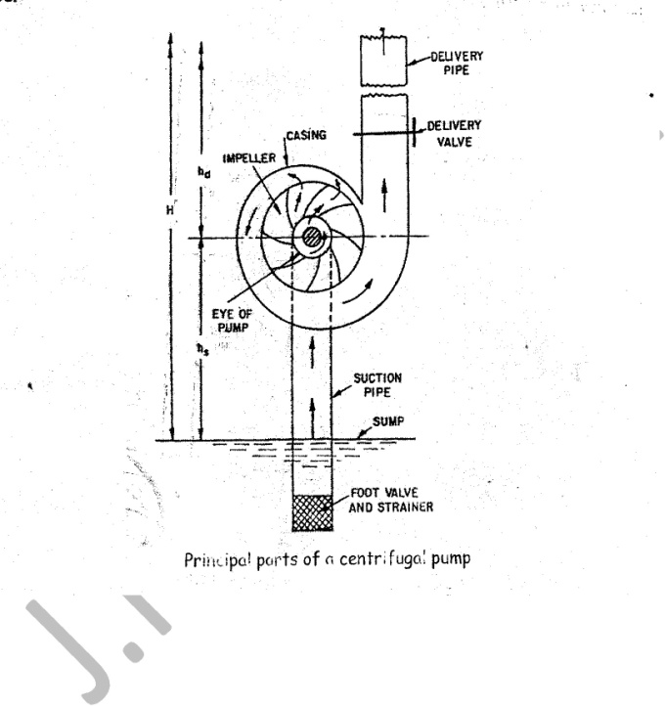

APPARATUS-: Centrifugal Pump Set – Up, Stop Watch, Meter Scale, etc.

THEORY-: The hydraulic machine which converts mechanical energy into hydraulic energy is called as the pump. The hydraulic energy is in the form of Pressure Energy. If Mechanical Energy is converted into pressure energy by means of Centrifugal Force which is acting on fluid. This hydraulic machine is called as a Centrifugal Pump. A Centrifugal Pump consists of an impeller which is rotating inside a spiral/volute casing. Liquid is admitted to the impeller in an axial direction through a central opening in it side called the Eye. It then flows radially outward & is discharged around the entire circumference into a casing. As the liquid flows through the rotating impeller, energy is imparted to the fluid, which results in increase in both: the Pressure Energy, and the Kinetic Energy. The name of pump Centrifugal is derived from the fact that, the discharge of liquid from the rotating impeller is due to the centrifugal head created in it when a liquid mass is rotated in a vessel. This results in a pressure rise throughout the mass, the rise at any point being proportional to the square of the Angular Velocity & the distance of the point from the axis of rotation.

PROCEDURE-:

- Switch on the motor and check the direction of rotation of pump in proper direction.

- Keep the discharge valve full open and allow the water to fall in main tank.

- No doubt the speed of the motor is controlled by the hand tachometer.

- The readings of suction and discharges are noted.

- Note the power consumed by pump from energy meter.

- Measure the discharge of the pump in the measuring tank by diverting the flow.

- Take few readings by varying the discharge.

PRECAUTIONS-:

- Priming is necessary if pump doesn’t give discharge.

- Leakage should be avoided at joints.

- Foot valve should be checked periodically.

- Lubricate the swiveled joints & moving parts periodically.

SPECIFICATIONS-:

Pump type -: Centrifugal Pump Type

Motor Power -: 05 HP

Energy Meter -: Electrical

Vacuum Gauge -: 0 to 760 mm of Hg (0 to -30 PSi)

Pressure Gauge -: 0 to 2.1 kg / cm²

Observations:

1. Area of measuring tank “ A” =…..cm²

- X = ……..cm

- N’= …..rpm

Observation Table -:

SR. NO. | M.T.R. | time | Qact | Pre. Guage |  | Vac. Guage |  | total head
IR (cm) | FR (cm) R (m) | t sec | t | Pd | Hd | Pv | H_{v} (m) | H= H_{d}+H_{v} +X
 |  |  |  | (kg/cm2) | (m) | (mm hg)

1

2

3

4

5

OUTPUT | SPEED | E.M.R. | INPUT | η %
WQH/75 | N | 5 REV
Calculations -:

- R = Final Reading – Initial Reading = F.R. – I.R. (m)

• Actual Discharge (m³/sec)

- Delivery head H_{d} = P_{d} / W

- Suction head Hv =

- Total head “ H ” = H_{d} + H_{v} + X

- Out put = W Q_{act} H/75

- Input = 3600 * 1.36 * 5/ N’ t

EXPERIMENT NO.: 09

Objective:
To study the flow characteristics over a hump placed in an open channel.

Apparatus Used:-

Tilting flume , Large chamber to study flow , Controlling meter to vary slope., Hook gauge/point gauge to measure the depth , Broad crested weirs/humps with different depth.
Principle:-
HUMP:
The raised bed of the channel at a certain location is called as hump.
WEIR:
It is the structure constructed across a river at a suitable location. It is commonly used to raise the
water level at a river to divert the required amount of water into an off taking canal. Weir can be
gated or ungated. Gated weir is called as barrage.
EFFECT OF HUMP HEIGHT ON THE DEPTH OF FLOW:
Height of hump is less than critical hump height then there will be sub-critical flow over the
hump, downstream of the hump and upstream of the hump. Depth of flow over the hump will
decrease by certain amount as there is a slight depression in the water surface. Further increase in
the height of hump will create more depression of water surface over the hump until finally the
depth becomes equal to the critical depth. When the hump height will be equal to critical depth
then there will be critical flow over the hump, sub-critical on the upstream side and super critical
just downstream of the hump.
CRITICAL HUMP HEIGHT:
The minimum hump height that causes the critical depth over the hump is called as critical hump
height.
CASE 1:
¬ y1 = y0
¬ y1 > y2> yc
¬ y1, y2 > yc
The flow conditions will be sub critical. At downstream depth is recovered after a long distance.

Procedure:-
1. Fix the slope of the flume.
2. Set the discharge in the flume having uniform flow.
3. Introduce a hump in the flume at certain location.
4. Note depth of flow at upstream side of hump, over the hump and downstream side of the
hump at certain point.
5. Repeat steps 2-4 for the other discharges.
6. Repeat the same procedure for different depth of hump.
7. Predict the type of flow at every section.
8. Compare depths with critical depth for every discharge value and report the type of flow.
9. Draw flow profile over the humps, upstream and downstream of the humps.

Result:-

EXPERIMENT NO.: 10

Objective:
To study the flow through a horizontal contraction in a rectangular channel.

Apparatus Used:-

Hydraulic bench, Notches, Rectangular, Hook and point gauge, Calibrated collecting tank, Stop watch
Principle:-
In open channel hydraulics, weirs are commonly used to either regulate or to measure the volumetric flow rate. They are of particular use in large scale situations such as irrigation schemes, canals and rivers. For small scale applications, weirs are often referred to as notches and invariably are sharp edged and manufactured from thin plate material. Water enters the stilling baffles which calms the flow. Then, the flow passes into the channel and flows over a sharp-edged notch set at the other end of the channel. Water comes of the channel in the form of a nappe is then directed into the calibrated collection tank. The volumetric flow rate is measured by recording the time taken to collect a known volume of water in the tank.A vertical hook and point gauge,mounted over the channel is used to measure the head of the flow above the crest.

Procedure:-
1. Keep the runner vane at require opening
- Keep the guide vanes at required opening
- Prime the pump if necessary
- Close the main sluice valve and them start the pump.
- Open the sluice valve for the required discharge when the pump motor switches from star to delta mode.
- Load the turbine by adding weights in the weight hanger. Open the brake drum cooling water gate valve for cooling the brake drum.
- Measure the turbine rpm with tachometer.

OBSERVATION:
breadth of the rectangular notch =
Area of collecting tank(A)=
Result:-

