**STRUCTURE ANALYSIS LAB**

**SUBJECT CODE:- RCE-453**

**INDEX**

1. To determine Flexural Rigidity (EI) of a given beam
2. To verify Maxwell’s Reciprocal theorem.
3. To find horizontal thrust in a three-hinged arch and to draw influence line diagrams for Horizontal Thrust end Bending moment.
4. To find horizontal thrust in a two hinged arch and to draw influence line diagrams for horizontal Thrust and bending moment.
5. To find Critical loan in struts with different end conditions.
6. To find deflections in Beam having unsymmetrical bending.
7. To find the determination of elastic deflection of curved beams.
8. To analysis the redundant joint.

**Experiment No. 1**

**Flexural rigidity**

**Aim: -** To find the value of flexural rigidity (EI) for a given beam and compare it with theoretical value

**Apparatus:** - Elastic Properties of deflected beam, weight’s, hanger, dial gauge, scale, and Verniar caliper.

**Formula:** - (1) Central upward deflection, y = W.a.L2 / 8y ……….. (1)

(2) EI = W.a. L2 / 8y ………… (2)

(3) Also it is known that EI for beam = E × bd3 /12 … …… (3)

Diagram:-



**Theory:** - For the beam with two equal overhangs and subjected to two concentrated loads W each at free ends, maximum deflection y at the centre is given bycentral upward deflection.Central upward deflection, y = W.a.L2 / 8EI

Where,

a = length of overhang on each side

W = load applied at the free ends

L = main span

E = modulus of elasticity of the material of the beam

I = moment of inertia of cross section of the beam

EI = W.a.L2 / 8y

It is known that, EI for beam = E × bd3 /12

Where, b = width of beam

d = depth of beam

**Procedure:** -

i) Find b and d of the beam and calculate the theoretical value of EI by Eq. (3).

ii) Measure the main span and overhang span of the beam with a scale.

iii) By applying equal loads at the free end of the overhang beam, find the central deflection y.

iv) Repeat the above steps for different loads.

**Observation**: - 1) Length of main span, L (cm) =

2) Length of overhang on each side, a (cm) =

3) Width of beam, b (cm) =

4) Depth of beam, d (cm) =

5) Modulus of elasticity, E (kg/cm2) = 2 x106

**Observation Table**:-

|  |  |  |  |  |
| --- | --- | --- | --- | --- |
| Sr. No | . Equal loads at the two  ends (kg) | Dial gauge reading at  the midspan of beam(cm) | EI from  Eq. ( 3 ) | EI from  Eq ( 2 ) |
|  |  |  |  |  |
|  |  |  |  |  |
| . |  |  |  |  |
|  |  |  |  |  |

**Calculation:** - Average values of EI from observation = ……cm4

Average values of EI from calculation = …….cm4

**Result:** - Flexural rigidity (EI) is found same theoretically and experimentally.

**Precaution:**- 1. Measure the center deflection y very accurately.

2. Ensure that the beam is devoid of initial curvature.

3. Loading should be within the elastic limit of the materials.

**Question:-**

1. What is the unit of flexural rigidity?
2. Which types of beam are used in defected beam apparatus?
3. Define the size of beam which is used is used in defected beam apparatus.
4. What is the difference b/w flexural rigidity and flexural stiffness?
5. What is flexural rigidity?

**Experiment No.2**

**Maxwell’s reciprocal theorem**

**Aim:** - To verify clerk Maxwell’s reciprocal theorem

**Apparatus**: - Clerk Maxwell’s Reciprocal Theorem apparatus, Weight’s, Hanger, Dial

Gauge, ScaleVerniar caliper.

**Diagram**:-



**Theory:** -

Maxwell theorem in its simplest form states that deflection of any point A of any elasticstructure due to load P at any point B is same as the deflection of beam due to same loadapplied at A. It is, therefore easily derived that the deflection curve for a point in a structure is the sameas the deflected curve of the structure when unit load is applied at the point for which theinfluence curve was obtained.

**Procedure**: -

i) Apply a load either at the centre of the simply supported span or at the free end of thebeam, the deflected form can be obtained.

ii) Measure the height of the beam at certain distance by means of a dial gauge before andafter loading and determine the deflection before and after at each point separately.

iii) Now move a load along the beam at certain distance and for each positions of the load, the deflection of the point was noted where the load was applied in step1.This deflection should be measured at each such point before and after the loading, separately.

iv) Plot the graph between deflection as ordinate and position of point on abssica the plot for graph drawn in step2 and 3.These are the influence line ordinates for deflection of thebeam.

**Observation Table**:-

|  |  |  |  |  |  |  |
| --- | --- | --- | --- | --- | --- | --- |
| Distance  from the  pinned  end | Load at central point/  cantilever end | | Deflection  of various  points  (mm) 2-3 | Load moving along  beam | | Deflection  of various  points  (mm) 5-6 |
| Beam  unloaded  Dial gauge  reading  (mm)2 | Beam  loaded  Dial  gauge  reading  (mm)3 | Beam  unloaded  Dial gauge  reading  (mm)5 | Beam  unloaded  Dial gauge  reading  (mm)5 | Beam  loaded  Dial gauge  reading  (mm)6 |  |
|  |  |  |  |  |  |  |
|  |  |  |  |  |  |  |
|  |  |  |  |  |  |  |

**Result:** - The Maxwell reciprocal theorem is verified experimentally and analytically.

**Precautio**n: - (i) Apply the loads without any jerk.

(ii) Perform the experiment at a location, which is away from any

(iii) Avoid external disturbance.

(iv) Ensure that the supports are rigid.

**Question:-**

1. What is the Maxwell’s reciprocal theorem or define the Maxwell’s reciprocal theorem?
2. What are the purpose of providing dial gauge and magnetic base in the apparatus?
3. Maxwell reciprocal theorem in structural analysis can be applied in-

A. all elastic structures B. plastic structure C. symmetrical structures only

D. prismatic element structure only

4. What is the difference B/W Maxwell’s reciprocal theorem and betties

**Experiment: 3**

**Three hinged arch**

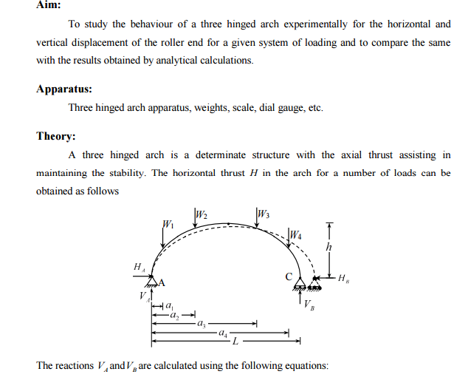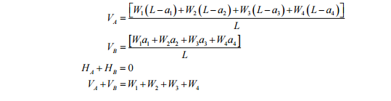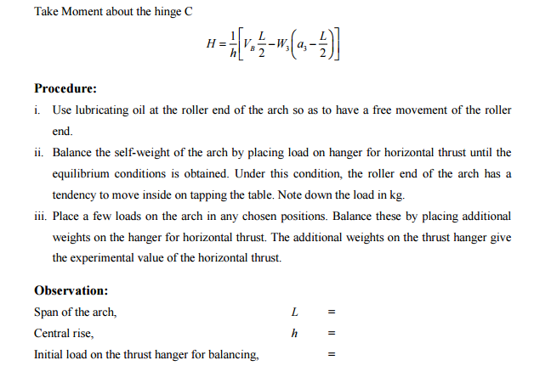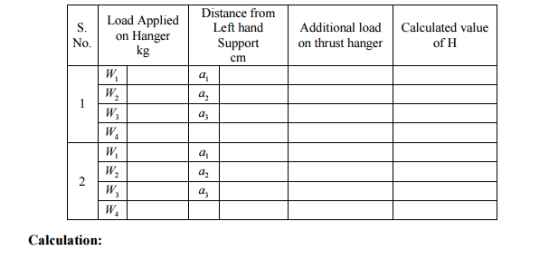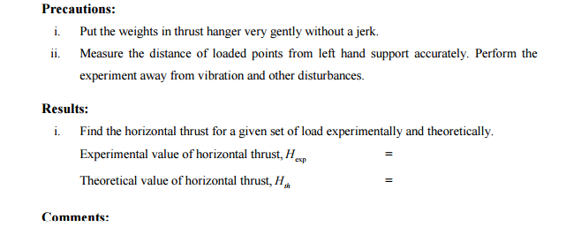

**Question:-**

* Define two hinge arches?
* What is the main difference in three hinged arch and two hinge arch?
* Three hinge arch structure are- (a) Determinate structure (b) Indeterminate Structure.
* The bending moment of three hinge arch is greater than the bending moment of beam. (a) True (b) False.
* Write the expression for bending moment at any section on the arch. Given- VA= Vertical load at point A , W1= load from end A at distance a, H= horizontal force at point A , x= e/s distance from A
* ON the basis of support conditions arches are classified / classified the arches on the basis support conditions.

**Experiment No. 4**

**Two hinged arch**

**Aim: -** To study two hinged arch for the horizontal displacement of the roller end for a given system of loading and to compare the same with those obtained analytically.

**Apparatus**: - Two Hinged Arch Apparatus, Weight’s, Hanger, Dial Gauge, Scale, Verniar Caliper.

**Formula**: - H = 5WL (a – 2a³ + a4)/8r

Where,

W= Weight applied at end support.

L= Span of two hinged arch.

r= rise of two hinged arch.

a = dial gauge reading.

**Diagram:-**



**Theory:** - The two hinged arch is a statically indeterminate structure of the first degree.The horizontal thrust is the redundant reaction and is obtained y the use of strain energy methods. Two hinged arch is made determinate by treating it as a simply supported curved beam and horizontal thrust as a redundant reaction. The arch spreads out under external load. Horizontal thrust is the redundant reaction is obtained by the use of strain energy method.

**Procedure**: -

i) Fix the dial gauge to measure the movement of the roller end of the model and keep the lever out of contact.

ii) Place a load of 0.5kg on the central hanger of the arch to remove any slackness and taking this as the initial position, set the reading on the dial gauge to zero.

iii) Now add 1 kg weights to the hanger and tabulated the horizontal movement of the roller end with increase in the load in steps of 1 kg. Take the reading up to 5 kg load. Dial gauge reading should be noted at the time of unloading also.

iv) Plot a graph between the load and displacement (Theoretical and Experimental) compare. Theoretical values should be computed by using horizontal displacement formula.

v) Now move the lever in contact with 200gm hanger on ratio 4/1 position with a 1kg load on the first hanger. Set the initial reading of the dial gauge to zero.

vi) Place additional 5 kg load on the first hanger without shock and observe the dial gauge reading.

vii) Restore the dial gauge reading to zero by adding loads to the lever hanger, say the load is w kg.

viii) The experimental values of the influence line ordinate at the first hanger position shall be 4w.

ix) Repeat the steps 5 to 8 for all other hanger loading positions and tabulate. Plot the influence line ordinates.

x) Compare the experimental values with those obtained theoretically by using equation (5).

**Observation Table**: - Horizontal displacement

|  |  |  |  |  |  |  |  |  |
| --- | --- | --- | --- | --- | --- | --- | --- | --- |
| Sr. No. | Central load (kg) | 0.0 | 1.0 | 2.0 | 3.0 | 4.0 | 5.0 | 6.0 |
|  | Observed horizontal  Displacement ( mm ) |  |  |  |  |  |  |  |
|  | Calculated horizontal  Displacement Eq. (4) |  |  |  |  |  |  |  |

**Sample Calculation**: - Central load (kg) =………..

Observed horizontal Displacement (mm) =

Calculated horizontal Displacement = H = 5WL (a – 2a³ + a4)/8r=…………..

**Result:**-The observed and horizontal displacement is nearly same.

**Precaution:** - 1.Apply the loads without jerk.

2. Perform the experiment away from vibration and other disturbances.**Question:-**

1. Define two hinged arch.
2. Two hinged arch structure are-

a. Determinate structure b. indeterminate structure

1. What is the application of two hinged arch?
2. Two hinged arch construction are complicated – TRUE/FLASE
3. The load carrying capacity of two hinge arch is higher than beams- TRUE/FLASE
4. The bending moment of arch is higher than the B.M. of beam- TRUE/FLASE

**Experiment No 5**

**Column and buckling**

**Object:** - To study behavior of different types of columns and find Euler’s buckling load for each case.

**Apparatus:** - Column Buckling Apparatus, Weights, Hanger, Dial Gauge, Scale, Verniar caliper.

**Diagram:-**





**Theory: -**If compressive load is applied on a column, the member may fail either by crushing or by buckling depending on its material, cross section and length. If member is considerably long in comparison to its lateral dimensions it will failby buckling. If a member shows signsof buckling the member leads to failurewith small increase in load. The load at which the member just buckles is called as crushing load. The buckling load, as given by Euler, can be found byusing following expression.

P = π² EI/le²

Where,

E = Modulus of Elasticity= 2 x 105 N/mm2 for steel

I = Least moment of inertia of column section

Le = Effective length of column

Depending on support conditions, four cases may arise. The effective length for each ofwhich are given as:

1. Both ends are fixed le = L/ 2

2. One end is fixed and other is pinned le = L/√ 2

3. Both ends are pinned le = L

4. One end is fixed and other is free le = 2L

**Procedure: -**

i) Pin a graph paper on the wooden board behind the column.

ii) Apply the load at the top of columns increasing gradually. At certain stage of loading the columns shows abnormal deflections and gives the buckling load.

iii) Not the buckling load for each of the four columns.

iv) Trace the deflected shapes of the columns over the paper. Mark the points of change

of curvature of the curves and measure the effective or equivalent length for each case separately.

v) Calculate the theoretical effective lengths and thus buckling loads by the expressions

given above and compare them with the observed values.

**Observation: -**

1) Width of strip (mm) b =

2) Thickness of strip (mm) t =

3) Length of strip (mm) L =

4) Least moment of inertia

I = bt³/12

**Observation Table:-**

|  |  |  |  |  |  |
| --- | --- | --- | --- | --- | --- |
| Sr. No | End condition | Euler’s  Buckling load (P = π² EI) | | Effective Length (mm) | |
| Theoretical | Observed | Theoretical | Observed |
| **1.** | Both ends fixed |  |  |  |  |
| **2.** | One end fixed and other pinned |  |  |  |  |
| **3.** | Both ends pinned |  |  |  |  |
| **4.** | One end fixed and other free. |  |  |  |  |

**Sample Calculation: -** Both ends fixed

Euler’s buckling load. = le²

Effective Length (mm) =.

**Result:-**The theoretical and experimental Euler’s buckling load for each case is foundnearly same.

**Question:-**

1. Define buckling?
2. What is the difference b/w buckling and twisting?
3. What is the difference b/w column and strut?
4. Define buckling facture?

**Experiment No-6**

**Deflections of beam**

**Aim:** - To verify the moment area theorem regarding the slopes and deflections of the beam.

**Apparatus:** - Moment of area theorem apparatus.

**Diagram:-**

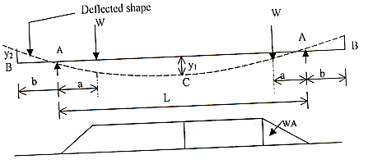

**Fig.-**

**Theory : -** According to moment area theorem

1. The change of slope of the tangents of the elastic curve between any two points ofthe deflected beam is equal to the area of M/EI diagram between these two points.

2. The deflection of any point relative to tangent at any other point is equal to themoment of the area of the M/EI diagram between the two points at which thedeflection is required.Slope at B= Y2 / bsince the tangent at C is horizontal due to symmetry,

Slope at B= shaded area / EI = 1 / EI [Wa2 / 2 + WA (L/2 – a)]

Displacement at B with respect to tangent at C

= (y1 + y2) = Moment of shaded area about B / EI

= 1 / EI [Wa2 / 2 (b+2/3a) + Wa(L/2 –a) (b+ a/2+L/2)]

**Procedure:** -

1. Measure a, b and L of the beam

2. Place the hangers at equal distance from the supports A and load them with equal loads.

3. Measure the deflection by dial gauges at the end B (y2) and at the center C (y1)

4. Repeat the above steps for different loads.

**Observation Table:**-

Length of main span, L (cm) =

Length of overhang on each side, a (cm) =

Modulus of elasticity, E (kg/cm2) = 2 x 106

|  |  |  |  |  |  |
| --- | --- | --- | --- | --- | --- |
| Sl. No. | Load at each  Hanger (kg) | Central  Deflection  Y1 (cm) | Deflection at  Free end y2  (cm) | Slope at B  Y2 / b | Deflection at  C=Deflection atB (y1) |
|  |  |  |  |  |  |

**Calculation:-**

1. Calculate the slope at B as y2 / b (measured value).

2. Compute slope and deflection at B theoretically from B.M.D. and compare withexperimental values.

3. Deflection at C = y1(measured value).

4. Deflection at C = Average calculated value

**Result: -**The slope and deflection obtained is close to the slope and deflection obtained by using moment area method.

**Precaution:-**

1. Apply the concentration loads without jerks.
2. Measures the deflection only when the beam attains ion.
3. Measures the deflection very carefully and accurately.
4. Check the accuracy and least count of dial gauges used for measuring deflections.

**Experiment:-7**

**Deflection of curved members**

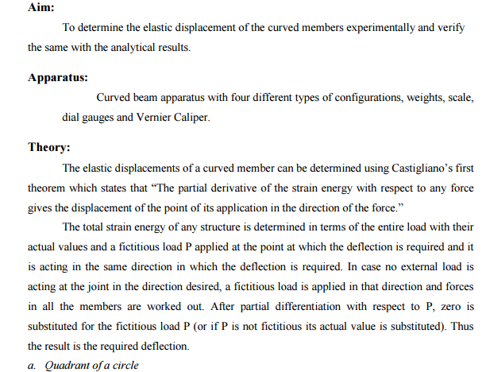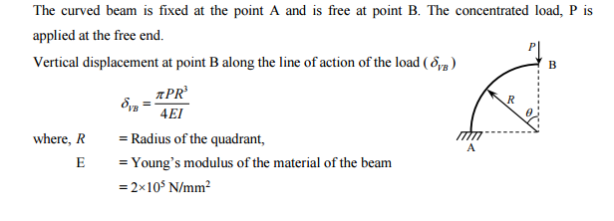

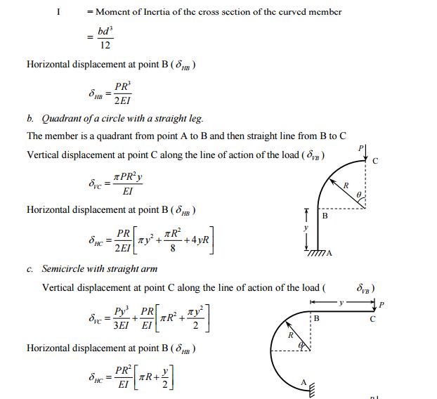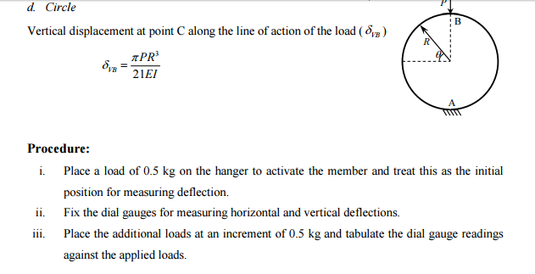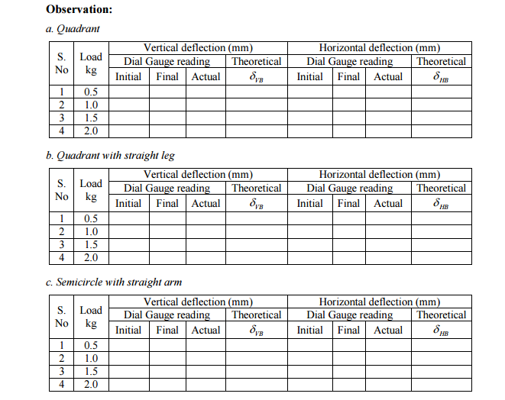

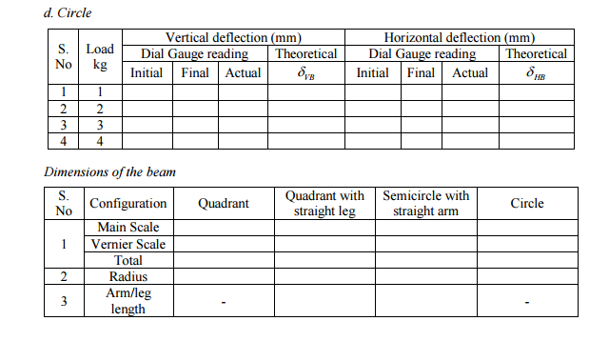**Calculation:**

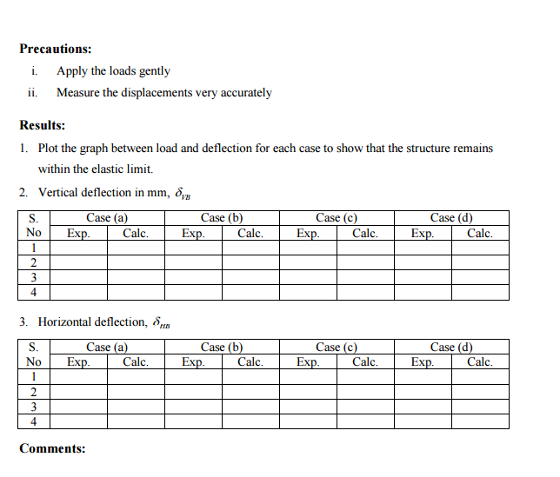

**Experiment:- 8**

**Analysis of Redundant frame**

**Aim:**

