**INDEX**

**LIST OF EXPERIMENTS**

|  |  |
| --- | --- |
| **S. No.** | **Practical** |
| 1 | To prepare conventional symbol chart based on the study of different types of topographical maps . |
| 2 | To measure bearings of a closed traverse by prismatic compass and to adjust the traverse by graphical method. |
| 3 | To find out reduced levels of given points using Auto/dumpy level. |
| 4 | To perform fly leveling with Auto/tilting level. |
| 5 | To study parts of a Vernier theodolite and measurement of horizontal and vertical angle  . |
| 6 | To measure horizontal angle between two objects by repetition /reiteration method. |
| 7 | To determine the height of a vertical structure (like chimney, water tank etc)using trigonometrical levelling by taking observations in single vertical plane |
| 8 | To study various parts of Electronic Theodolite, Total Station and practice for Measurement of distance, horizontal and vertical angles. |
| 9 | To set out a simple circular curve by Rankin’s method |
| 10 | To plot the contour map for a given area by direct method. |

**EXPERIMENT NO- 1**

**OBJECTIVE:** To prepare conventional symbol chart based on the study of different types of topographical maps.

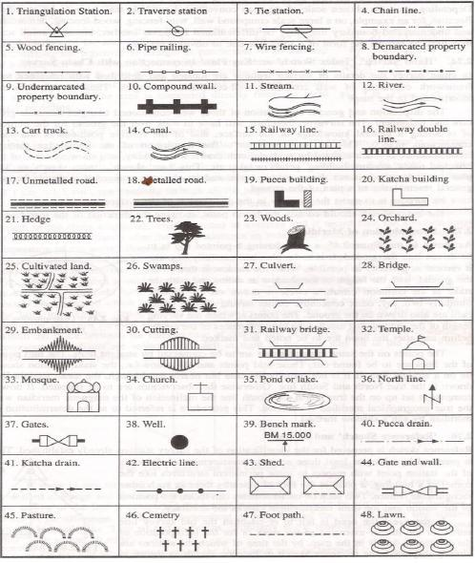

**EXPERIMENT NO- 2**

**OBJECTIVE:** To measure the bearings of a closed traverse by prismatic compass and to adjust the traverse by graphical method.

**INSTRUMENTS:**Prismatic compass, chain, ranging rods.

**SKETCH:**

**B C**

**A D**

**F E**

**PROCEDURE:**

» Fix the closed traverse A B C D E&F.

» Set up the compass at the station ‘A’.

» Perform the temporary adjustments.

» Sight the object at ‘B’ and note down the FB of line AB and measure the distance.

» Sight the object at F and note down the BB of EA.

» Sight the instrument to station ‘B’ performs all the temporary adjustments.

» Sight the object at ‘A’ and take the ‘BB’ of ‘AB’.

» Take ‘FB’ of ‘BC’ and measure the length of ‘BC’.

» Check whether the difference of ‘FB’ and ‘BB’ is 180º or not, at all stations.

» Continue the same process all at other stations.

**TABULAR FORM FOR CLOSED TRAVERSE:-**

|  |  |  |  |  |  |  |
| --- | --- | --- | --- | --- | --- | --- |
| **Sr. No.** | **Line** | **Length** | **F.B** | **B.B** | **INCLUDED ANGLE** | **Remarks** |
|  |  |  |  |  |  |  |
|  |  |  |  |  |  |  |
|  |  |  |  |  |  |  |
|  |  |  |  |  |  |  |

**FORMULA:** Included angle = B.B of previous line – F.B of next line.

**CHECK:** The sum of the included angles should be equals to (2n-4) x 90º (Where ‘n’ is number of sides of the)

**Questions**

1. Name different types of compass.
2. What is declination?
3. Name different sources of local attraction.
4. What is True bearing and Magnetic bearing?
5. A negative declination shows that the magnetic meridian is to the….
   * 1. Eastern side of the true meridian
     2. Western side of the true meridian
     3. Southern side of the true meridian
     4. None of the above
6. Explain azimuth.
7. The prismatic compass and surveyor's compass  
   a)give whole circle bearing (WCB) of a line and quadrantal bearing (QB) of a line respectively  
   b)both give QB of a line and WCB of a line  
   c)both give QB of a line  
   d)both give WCB of a line
8. For a line AB  
    a)the forebearing of AB and back bearing of AB differ by 180°  
    b)the forebearing of AB and back bearing of BA differ by 180°  
   c)both (a) and (b) are correct.  
   d)none is correct

**EXPERIMENT NO- 3**

**OBJECTIVE**: To find out reduced levels of given points using Auto/dumpy level.

**APPARATUS**: Dumpy level, leveling staff



Fig. Dumpy Level

**THEORY:**

**Levelling:** The art of determining and representing the relative height or elevation of different object/points on the surface of earth is called leveling. It deals with measurement in vertical plane. By leveling operation, the relative position of two points is known whether the points are near or far off. Similarly, the point at different elevation with respect to a given datum can be established by leveling.

**LEVELLING INSTRUMENTS:-** The instrument which are directly used for leveling operation are:-Level, Leveling staffLevel: - An instrument which is used for observing staff reading on leveling staff kept over different points after creating a line of sight is called a level.

**Dumpy Level:** The difference in elevation between the point then can worked out. A level essentiallyconsists of the following points:

1) Leveling Heads

2) Limb plate

3) Telescope

4) Bubble tube

5) Tripod stand

Telescope consists of two tubes, one slide into the other and fitted with lens and diaphragm having cross hairs. it creates a line of sight by which the reading on the staff is taken The essential parts of a telescope are1) body 2) object glass 3)Eye-piece 4) Diaphragm 5) Ray shade 6) The rack and pinion arrangement 7) Focusing screw 8) Diaphragm screw.

**Dumpy level:** The dumpy level is simple, compact and stable instrument. The telescope is rigidly fixed toitssupports. Hence it cannot be rotated about its longitudinal axis or cannot be removed from its support. The name dumpy is because of its compact and stable construction. The axis of telescope is perpendicular to the vertical axis of the level. The level tube is permanently placed so that its axis lies in the same vertical plane of the telescope but it is adjustable by means of captain head not at one end. The ray shade is provided to protect the object glass. A clamp and slow motion screw are provided in modern level to control the movement of spindle, about the vertical axis. The telescope has magnifying power of about thirty diameters. The level tube is graduated to 2mm divisions and it has normally a sensitiveness of 20seconds of are per graduation. The telescope may be internally focusing or externalFocusing type.

*Adjustment of the level*

The level needs two type of adjustment

1) Temporary adjustment and

2) Permanent adjustment

Temporary adjustments of dumpy level

These adjustments are performed at each set-up the level before taking any observation.

**A) Setting up the level: -** this includes

1) Fixing the instrument in the tripod: - the tripod legs are well spread on the ground with tripod head nearly level and at convenient height. Fix up the level on the tripod.

2) Leg adjustment:- Bring all the foot screws of the level in the centre of their run .Fix any two legs firmly into the ground by pressing them with hand and move the third leg to leg to right or left until the main bubble is roughly in the centre. Finally the legs are fixed after centering approximately both bubbles. This operation will save the time required for leveling.

**B) Leveling: -** Leveling is done with the help of foot screws and bubbles. The purpose ofleveling is to make the vertical axis truly vertical. The method of leveling the instrument depends upon whether there are three foot screws or four foot screws. In all modern instruments three foot screws are provided and this method only is described.

1) Place the telescope parallel to pair of foot screws.

2) Hold these two foot screw between the thumb and first finger of each hand and turn them uniformly so that the thumbs move either toward each other until the bubble is in centre.

3) Turn the telescope through 90°so that it lies over the third foot screw.

4) Turn this foot screw only until the bubble is centered.

5) Bring the telescope back to its original position without reversing the eye pieceand object glass ends.

6) Again bring the bubble to the centre of its run and repeat these operation until the bubble remains in the centre of its run in both positions which are at right angle to each other.

7) Now rotate the instrument through 180°, the bubble should remain in centre provided the instrument is in adjustment: if not, it needs permanent adjustment.

**C) Focusing the eye piece:-** To focus the eye piece, hold a white paper in front of the object glass ,and move the eye piece in or out till the cross hairs are distinctly seen. Care should be taken that the eye piece is not wholly taken out ,sometimes graduation are provided at the eye piece and that one can always remember theparticular graduation position to suit his eyes,This will save much time of focusing the eye piece.

**(D) Focusing the object glass:** - Direct the telescope to the leveling staff and on looking through the telescope, turn the focusing screw until the image appears clears and sharp. The image is thus formed inside the plane of cross hairs, Parallax, if any is removed by exact focusing. It may be noted that parallax is completely eliminated when there is no change in staff reading after moving the eye up and down. Reduced Levels the system of working out the reduced level of the points from staff reading taken in the field is called as reduced level (R.L) of a points is the elevation of the point with reference to the same datum. There are two systems of reduced levels

1) The plane of collimation system (H.I. method)

2) The Rise and fall system

1) The plane of collimation system (H.I. method)

In this system, the R.L. of plane of collimation (H.I) is found out for every set-up of thelevel and then the reduced levels of the points are worked out with the respectiveplane of collimation as described below.

1) Determine the R.L. of plane of collimation for the first set up of the level by adding B.S. to the R.L. of B.M. i.e. (R.L of plane of collimation= R.L. of B.M. +B.S.)

2) Obtained the R.L. of the intermediate points and first change point bysubtracting the staff readings (I.S. and F.S. from the R.L. of plane of collimation (H.I). (R.L. of a point=R.L of plane of collimation H.I.-I.S or F.S)

3) When the instrument is shifted and set up at new position a new plane ofcollimation is determined by addition of B.S. to the R.L of change point. Thus thelevels from two set-ups of the instruments can be correlated by means of B.S.and F.S. taken on C.P.

4) Find out the R.L.s of the successive points and the second C.P. by subtracting their staff readings from this plane of collimation R.L.

5) Repeat the procedure until all the R.Ls are worked out.

**Observation table:-**

|  |  |  |  |  |  |  |
| --- | --- | --- | --- | --- | --- | --- |
| **STATION** | **Reading** | | | **Height of instrument** | **Reduced Level** | **Remarks** |
| **B.S** | **I.S.** | **F.S.** |
|  |  |  |  |  |  |  |
|  |  |  |  |  |  |  |
|  |  |  |  |  |  |  |
|  |  |  |  |  |  |  |

**Questions**

1. Name different types of leveling instrument.
2. What is least count of staff reading?
3. What is Bench Mark?
4. Name different types of method of leveling.
5. Why temporary adjustment is done?
6. Which of the following errors can be neutralized by setting the level midway between the two stations ?  
   a)error due to curvature only.  
   b)error due to refraction only.  
   c)error due to both curvature and re-fraction.  
   d)none of the above.
7. Height of instrument method of leveling is  
   a)more accurate than rise and fall method.  
   b)less accurate than rise and fall method.  
   c)quicker and less tedious for large number of intermediate sights.  
   d)none of the above
8. The rise and fall method  
   a)is less accurate than height of instrument method.  
   b)is not suitable for leveling with tilting levels.  
   c)provides a check on the reduction of intermediate point levels.  
   d)quicker and less tedious for large number of intermediate sights.

**EXPERIMENT NO- 4**

**OBJECTIVE**: To perform fly leveling with Auto/tilting level.

**APPARATUS**: Dumpy level, leveling staff



Fig. Dumpy Level

**THEORY:**

**Levelling:** The art of determining and representing the relative height or elevation of different object/points on the surface of earth is called leveling. It deals with measurement in vertical plane. By leveling operation, the relative position of two points is known whether the points are near or far off. Similarly, the point at different elevation with respect to a given datum can be established by leveling.

**LEVELLING INSTRUMENTS:-** The instrument which are directly used for leveling operation are:-Level, Leveling staffLevel: - An instrument which is used for observing staff reading on leveling staff kept over different points after creating a line of sight is called a level.

**Dumpy Level:** The difference in elevation between the point then can worked out. A level essentiallyconsists of the following points:

1) Leveling Heads

2) Limb plate

3) Telescope

4) Bubble tube

5) Tripod stand

Telescope consists of two tubes, one slide into the other and fitted with lens and diaphragm having cross hairs. it creates a line of sight by which the reading on the staff is taken The essential parts of a telescope are1) body 2) object glass 3)Eye-piece 4) Diaphragm 5) Ray shade 6) The rack and pinion arrangement 7) Focusing screw 8) Diaphragm screw.

**Dumpy level:** The dumpy level is simple, compact and stable instrument. The telescope is rigidly fixed toitssupports. Hence it cannot be rotated about its longitudinal axis or cannot be removed from its support. The name dumpy is because of its compact and stable construction. The axis of telescope is perpendicular to the vertical axis of the level. The level tube is permanently placed so that its axis lies in the same vertical plane of the telescope but it is adjustable by means of captain head not at one end. The ray shade is provided to protect the object glass. A clamp and slow motion screw are provided in modern level to control the movement of spindle, about the vertical axis. The telescope has magnifying power of about thirty diameters. The level tube is graduated to 2mm divisions and it has normally a sensitiveness of 20seconds of are per graduation. The telescope may be internally focusing or externalFocusing type.

*Adjustment of the level*

The level needs two type of adjustment

1) Temporary adjustment and

2) Permanent adjustment

Temporary adjustments of dumpy level

These adjustments are performed at each set-up the level before taking any observation.

**A) Setting up the level: -** this includes

1) Fixing the instrument in the tripod: - the tripod legs are well spread on the ground with tripod head nearly level and at convenient height. Fix up the level on the tripod.

2) Leg adjustment:- Bring all the foot screws of the level in the centre of their run .Fix any two legs firmly into the ground by pressing them with hand and move the third leg to leg to right or left until the main bubble is roughly in the centre. Finally the legs are fixed after centering approximately both bubbles. This operation will save the time required for leveling.

**B) Leveling: -** Leveling is done with the help of foot screws and bubbles. The purpose ofleveling is to make the vertical axis truly vertical. The method of leveling the instrument depends upon whether there are three foot screws or four foot screws. In all modern instruments three foot screws are provided and this method only is described.

1) Place the telescope parallel to pair of foot screws.

2) Hold these two foot screw between the thumb and first finger of each hand and turn them uniformly so that the thumbs move either toward each other until the bubble is in centre.

3) Turn the telescope through 90°so that it lies over the third foot screw.

4) Turn this foot screw only until the bubble is centered.

5) Bring the telescope back to its original position without reversing the eye pieceand object glass ends.

6) Again bring the bubble to the centre of its run and repeat these operation until the bubble remains in the centre of its run in both positions which are at right angle to each other.

7) Now rotate the instrument through 180°, the bubble should remain in centre provided the instrument is in adjustment: if not, it needs permanent adjustment.

**C) Focusing the eye piece:-** To focus the eye piece, hold a white paper in front of the object glass ,and move the eye piece in or out till the cross hairs are distinctly seen. Care should be taken that the eye piece is not wholly taken out ,sometimes graduation are provided at the eye piece and that one can always remember theparticular graduation position to suit his eyes,This will save much time of focusing the eye piece.

**(D) Focusing the object glass:** - Direct the telescope to the leveling staff and on looking through the telescope, turn the focusing screw until the image appears clears and sharp. The image is thus formed inside the plane of cross hairs, Parallax, if any is removed by exact focusing. It may be noted that parallax is completely eliminated when there is no change in staff reading after moving the eye up and down. Reduced Levels the system of working out the reduced level of the points from staff reading taken in the field is called as reduced level (R.L) of a points is the elevation of the point with reference to the same datum. There are two systems of reduced levels

1) The plane of collimation system (H.I. method)

2) The Rise and fall system

1) The plane of collimation system (H.I. method)

In this system, the R.L. of plane of collimation (H.I) is found out for every set-up of thelevel and then the reduced levels of the points are worked out with the respectiveplane of collimation as described below.

1) Determine the R.L. of plane of collimation for the first set up of the level by adding B.S. to the R.L. of B.M. i.e. (R.L of plane of collimation= R.L. of B.M. +B.S.)

2) Obtained the R.L. of the intermediate points and first change point bysubtracting the staff readings (I.S. and F.S. from the R.L. of plane of collimation (H.I). (R.L. of a point=R.L of plane of collimation H.I.-I.S or F.S)

3) When the instrument is shifted and set up at new position a new plane ofcollimation is determined by addition of B.S. to the R.L of change point. Thus thelevels from two set-ups of the instruments can be correlated by means of B.S.and F.S. taken on C.P.

4) Find out the R.L.s of the successive points and the second C.P. by subtracting their staff readings from this plane of collimation R.L.

5) Repeat the procedure until all the R.Ls are worked out.

**Observation table:-**

|  |  |  |  |  |  |  |
| --- | --- | --- | --- | --- | --- | --- |
| **STATION** | **Reading** | | | **Height of instrument** | **Reduced Level** | **Remarks** |
| **B.S** | **I.S.** | **F.S.** |
|  |  |  |  |  |  |  |
|  |  |  |  |  |  |  |
|  |  |  |  |  |  |  |
|  |  |  |  |  |  |  |

**Questions**

1. Name different types of leveling instrument.
2. What is least count of staff reading?
3. What is Bench Mark?
4. Name different types of method of leveling.
5. Why temporary adjustment is done?
6. Which of the following errors can be neutralized by setting the level midway between the two stations ?  
   a)error due to curvature only.  
   b)error due to refraction only.  
   c)error due to both curvature and re-fraction.  
   d)none of the above.
7. Height of instrument method of leveling is  
   a)more accurate than rise and fall method.  
   b)less accurate than rise and fall method.  
   c)quicker and less tedious for large number of intermediate sights.  
   d)none of the above
8. The rise and fall method  
   a)is less accurate than height of instrument method.  
   b)is not suitable for leveling with tilting levels.  
   c)provides a check on the reduction of intermediate point levels.  
   d)quicker and less tedious for large number of intermediate sights.

**EXPERIMENT NO- 5**

**OBJECTIVE:** To study parts of a Vernier theodolite and measurement of horizontal and verticalangle.

**APPARATUS**:- Theodolite, three ranging rods,

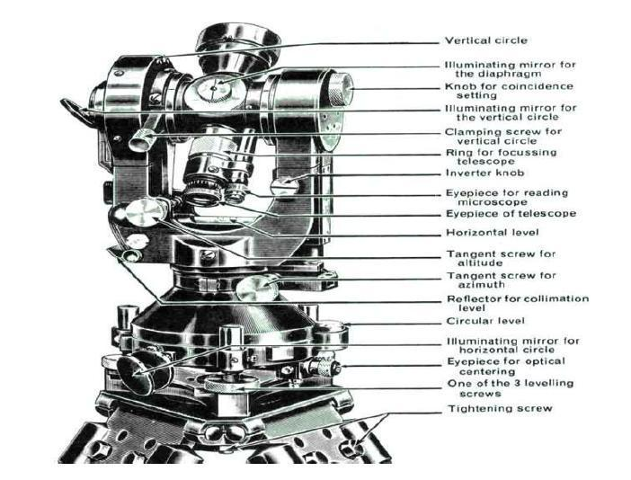

Fig. Vernier Theodolite

**THEORY**: Theodolite is an instrument designed for the measurement of horizontal and vertical angle. It ismost precise method it is also used for laying of horizontal angles locating points on line prolonging thesurvey line establishing the gradient, determination of difference in the elevation setting out curve.Theodolites are of two types - transit and non transit. Transit theodolite is commonly used nowadays.In transit theodolitetelescope can be revolved a complete revolution about its horizontal axis in a vertical plane. A transit theodoliteconsists of essential part.

1) Leveling head: It supports the main working parts of the instrument and screws on a tripod. The headcomprises of two parts

a) A leveling foot screws for leveling the instrument i.e. for marking vertical axis truly vertical.

b) A movable head or centering arrangement for centering the vertical axis accurately over a station point.

2) A lower level circular horizontal metal plate: It carries a circular graduated arc. The lower plate is attachedto a vertical metal spindle (outer axis) which works in vertical bearing and a form a part of leveling head. Itmay be graduated in degree and half degree or a degree 1/3 of degrees .the upper plate carries an index andvernier or micrometer towards fine reading on gradated horizontal circle .the upper plate carries standard useof for supporting the telescope and the spirit level used for leveling the instrument.3) A telescope: The telescope is pivoted between the standard at right angles to the horizontal axis . It can berotated about its horizontal axis in a vertical plane. The telescope is provided with the focusing screw,Clamping screw and tangent screw.

4) A circular graduated are carried on vertical circle: It is attached to the horizontal axis of the telescope, it isusually divided into 4 quadrants, but in some instruments it is graduated continuously from 0-3600.Thegraduation in each quadrant are numbered from 0-900 in opposite direction. The subdivisions of vertical circleare similar to those of vertical circle.

**MESURMENT OF VERTICAL ANGLE**

A vertical angle is the angle between the inclined line of sight to an object and the horizontal. It may be anangle of elevation or on angle of depression according as the point is above or below the horizontal planepassing through the trunnion axis of the instrument. To measure angle of elevation or depression LOM shownin fig. proceed asfollows:

1) Set up the theodolite at station point O and level it accurately with reference to the altitude level.

2) Set vertical verniers C and D exactly to zero by using the vertical circle clamp and tangent screw, while thealtitude level should remain in the centre of its run. Also the face of the theodolite should be left.

3) Release the vertical circle clamp screw and rotate the telescope in vertical plane so as to bisect the object M.tighten the vertical circle clamp and exactly bisect the object by slow motion screw.

4) Read both verniers C and D. the mean of the tow readings gives the value of the required angle.

5) Similar observation may be made with other face. The average of the tow values thus obtained gives thevalue of the required angle which is free from instrumental errors.

6) Similarly the angle of depression can be measured following the above steps.

To measure the vertical angle between two points L and M

Sometimes it is required to measure vertical angle between two points L and M. There can be three possibilities.

(a) One point is above the line of sight and the other is below the line of sight thenangle LOM as shown in fig will be equal to (<P +<Q )

(b) Both the points are above the line of sight. Then the angle LOM= <P -<Q

(c) Both the points are below the line of sight, then the angle LOM= <P -<Q (Refer Fig. 3)

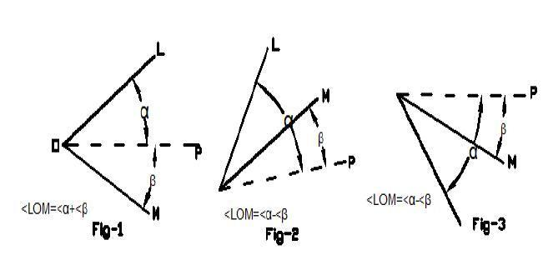

To measure the angle between two points L and M proceed as follows:

1) Set the theodolite at station point O and accurately level it.

2) Bisect the flag at L as explained already and take the reading on the verniers C and D. Calculate the meanangle.

3) Bisect the flag at M as before and take the reading on the verniers C and D.

Calculate the mean angle.

3)The sum or difference of these angles will give the value of the vertical angle between points L and M

**Result: -…………………………..**

**Questions**

1. Why a type of theodolite is called a transit theodolite?
2. What are the temporary adjustments of the theodolite?
3. What is the least count of vernier theodolite?
4. Theodolite is an instrument used for

a)Tightening the capstan-headed nuts of level tube  
b)measurement of horizontal angles only  
c)measurement of vertical angles only  
d)measurement of both horizontal and vertical angles

1. The process of turning the telescope about the vertical axis in horizontal plane is known as:   
   a)transiting  
   b)reversing  
   c)plunging  
   d)swinging
2. Size of a theodolite is specified by  
   a)the length of telescope  
   b)the diameter of vertical circle  
   c)the diameter of lower plate  
   d)the diameter of upper plate
3. .A telescope is said to be inverted if it’s  
   a)vertical circle is to its right and the bubble of the telescope is down  
   b)vertical circle is to its right and the bubble of the telescope is up  
   c)vertical circle is to its left and the bubble of the telescope is down  
   d)vertical circle is to its left and the bubble of the telescope is up
4. The following sights are taken on a "turning point"  
   a)foresight only  
   b)backsight only  
   c)foresight and backsight  
   d)foresight and intermediate sight

**EXPERIMENT NO- 6**

**OBJECTIVE:** Tomeasure horizontal angle between two objects by repetition /reiteration method.

**Apparatus Required:** Theodolite with tripod, peg, ranging rod, plumb-bob

**Procedure:-**

1) Let LOM is the horizontal angle to be measured as shown in fig. O is the station point fixed on the ground by a peg. Set up the theodolite over the peg 'o' and level it.

2) Set the horizontal graduated circle vernier A to read zero or 360° by upper clamp screw and slow motion screw. Clamp the telescope to bisect the bottom shoe of the flag fixed at point 'L' and tighten the lower clamp. Exactly intersect the centre of the bottom shoe by means of lower slow motion screw. Check that the face of the theodolite should be left and the telescope in normal position.

3) Check the reading of the vernier A to see that no slip has occurred .Also see that the plate levels are in the centre of their run. Read the vernier B also.

4) Release the upper clamp screw and turn the theodolite clockwise. Biset the flag bottom shoe fixed at point M by a telescope. Tighten the upper clamp screw and bisect the shoe exactly by means of upper slow motion screw.

5) Note the reading on both the vernier to get the approximate value of the angle LOM.

6) Release the lower clamp screw and rotate the theodolite anticlockwise aiazimuth.Bisect again the bottom shoe of the flag at 'L' and tighten the lower clamp screw. By means of slow motion screw bisect exactly the centre of the shoe.

7) Release now the upper clamp screw and rotate the theodolite clockwise. Bisect the bottom shoe of the flag fixed at M and tighten the upper clamp screw. By means of slow motion screw bisect exactly the centre of the shoe. The vernier readings will be now twice the of the angles.

8) Repeat the process until the angle is repeated the required number of times (usually 3). Add 360° for every complete revaluation to the final reading and divided the total angle by number of repetitions to get the value of angle LOM.

9) Change the face of the theodolite the telescope will now be inverted. Rrpeat the whole process exactly in the above manner and obtain value of angle LOM.

10) The average horizontal angle is then obtained by taking the average of the two angles obtained with face left and face right.

11) Usually three repetitions face left and three with face right should be taken and the mean angle should be calculated.

**L M**

**O**

**Result:**The horizontal angle,<LOM =………………………

**Questions**

1. Which of the following errors is not eliminated by the method of repetition of horizontal angle measurement?  
   a)error due to eccentricity of verniers  
   b)error due to displacement of station signals  
   c)error due to wrong adjustment of line of collimation and trunion axis  
   d)error due to inaccurate graduation
2. For which of the following permanent adjustments of theodolite, the spire test is used ?  
   a)adjustment of plate levels  
   b)adjustment of line of sight  
   c)adjustment of horizontal axis  
   d)adjustment of altitude bubble and vertical index frame
3. Which of the following errors is not eliminated by the method of repetition of horizontal angle measurement?  
   a)error due to eccentricity of verniers  
   b)error due to displacement of station signals  
   c)error due to wrong adjustment of line of collimation and trunion axis  
   d)error due to inaccurate graduation
4. The error due to eccentricity of inner and outer axes can be eliminated by  
   a)reading both verniers and taking the mean of the two  
   b)taking both face observations and taking the mean of the two  
   c)double sighting  
   d)taking mean of several readings distributed over different portions of the graduated circle

1. In the double application of principle of reversion, the apparent error is  
   a)equal to true error  
   b)half the true error  
   c)two times the true error  
   d)four times the true error

**EXPERIMENT NO- 7**

**OBJECTIVE:**To determine the height of a vertical structure (like chimney, water tank etc)using trigonometrical levelling by taking observations in single vertical plane

**APPARATUS**:- Theodolite, three ranging rods,

**MESURMENT OF VERTICAL ANGLE**

A vertical angle is the angle between the inclined line of sight to an object and thehorizontal. It may be an angle of elevation or on angle of depression according as thepoint is above or below the horizontal plane passing through the trunnion axis of theinstrument. To measure angle of elevation or depression LOM shown in fig. proceedasfollows:

1) Set up the theodolite at station point O and level it accurately with reference to thealtitude level.

2) Set vertical vernies C and D exactly to zero by using the vertical circle clamp andtangent screw, while the altitude level should remain in the centre of its run. Also theface of the theodolite should be left.

3) Release the vertical circle clamp screw and rotate the telescope in vertical plane soas to bisect the object M. tighten the vertical circle clamp and exactly bisect theobject by slow motion screw.

4) Read both verniers C and D. the mean of the tow readings gives the value of therequired angle.

5) Similar observation may be made with other face. The average of the tow valuesthus obtained gives the value of the required angle which is free from instrumentalerrors.

6) Similarly the angle of depression can be measured following the above steps.

To measure the vertical angle between two point L and M.

Sometimes it is required to measure vertical angle between two points L and M. Therecan be three possibilities.

(a) One point is above the line of sight and the other is below the line of sight thenangle LOM as shown in fig will be equal to (<P +<Q )

(b) Both the points are above the line of sight. Then the angle LOM= <P -<Q

c) Both the points are below the line of sight, then the angle LOM= <P -<Q

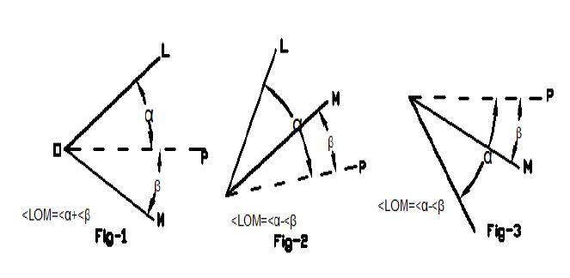

The average value of vertical is found to be------------

**Calculation:-**

**Result:**The height is………..

**Questions**

1. Which of the following errors can be eliminated by taking mean of both face observations?  
   a)error due to imperfect graduations  
   b)error due to eccentricity of verniers  
   c)error due to imperfect adjustment of plate levels  
   d)error due to line of collimation not being perpendicular to horizontal axis**.**
2. Which of the following errors cannot be eliminated by taking both face observations?  
   a) error due to horizontal axis not being perpendicular to the vertical axis  
   b)index error i.e. error due to imperfect adjustment of the vertical circle vernier  
   c)error due to non-parallelism of the axis of telescope level and line of collimation  
   d)none of the above**.**
3. If altitude bubble is provided both on index frame as well as on telescope of a theodolite, then the instrument is levelled with reference to  
   i)    altitude bubble on index frame  
   ii)   altitude bubble on index frame if it is to be used as a level  
   iii) altitude bubble on telescope  
   iv) altitude bubble on telescope if it is to be used as a level The correct answer is  
   a)only (i)  
   b)both (i) and (iv)**.**  
   c)only (iii)  
   d)both (ii) and (iii)

**EXPERIMENT 8**

**OBJECTIVE:**To study various parts of Electronic Theodolite, Total Station and practice for Measurement of distance, horizontal and vertical angles.

**Total Station**

A total station is an electronic/optical instrument used in modern surveying. The total stationis an electronic theodolite (transit) integrated with an electronic distance meter (EDM) to readslope distances from the instrument to a particular point.

It can perform the following functions:-

• Distance measurement

• Angular measurement

• Data processing

• Digital display of point details

• Sorting of data in an electronic field book

The important features of total station areKey board Control

Digital panel: - The panel displays the values of distance, angle, height and the coordinatesof the observed point where the reflector is kept.

Remote height object: - The heights of some inaccessible objects such as towers can beRead directly.Themicroprocessor provided in the instrument applies the correction forcurvature and mean refraction automatically.

Traversing program: - The co-ordinates of the reflector and the angle of bearing of thereflector can be stored and can be recalled for next set up of the instrument.

Setting out for distance ,direction and height:- Where ever a particular direction and ahorizontal distance is to be entered for the purpose of locatingthe point on the ground, using a target, then the instrument displays the angle throughwhich the theodolite has to be turned and the distance by which the reflector shouldmove.

**Automatic level**

An automatic level is a special surveying (leveling) instrument which contains an opticalcompensation which maintains a horizontal line of sight or line of collimation eventhough the instrument is slightly tilted.

**Questions**

1. The sensitivity of a bubble tube can be increased by  
   a)increasing the diameter of the tube**.**  
   b)decreasing the length of bubble  
   c)increasing the viscosity of liquid  
   d)decreasing the radius of curvature of tube
2. With the rise of temperature, the sensitivity of a bubble tube………  
   a)decreases**.**  
   b)increases  
   c)remains unaffected  
   d)none of the above
3. Sensitiveness of a level tube is designated by  
   a)radius of level tube**.**  
   b)length of level tube  
   c)length of bubble of level tube  
   d)none of the above
4. What are the fundamental mental measurements of T.S.?
5. What is the principle of Total Station?
6. What is the least count of T.S. for angle measurement?
7. What is reflector in T.S?
8. What is E.D.M?

**EXPERIMENT NO – 9**

**OBJECTIVE:-**To set out a simple circular curve by Rankin’s method

**Problem:-**Two tangent intersect at a point the defection angle being ____º.Calculate all the data necessary for setting out a simple curve of radius 32.

**Instruments used:** Theodolite, ranging rods, pegs, arrows etc.

**Theory:-**A deflection angle to any point on the curve is the angle at Point of Curve (PC) between the tangent and the chord from the P C to that point.

**RANKINES METHOD OF DEFLECTION ANGLES**

T1V= rear tangent

T1 = Point to curve

= the tangential angles or the angles with each of the successive chordsT1A, AB, BC etc. Makes with the respective tangents to the curve at T1, A, B etc

= Total tangential angles of the deflection angles to the points A, B, C etc

C1, C2, C3 = lengths f the chords T1A, AB, BC etc...

A1A = tangent to the curve at A

= 1719 C minutes

R

For the first chord= tangential angle for the chord AB

*Hence, the deflection angle for any chord is equal to the deflection angle for theprevious chord plus the tangential angle for that chord.*

**Procedure:**

1. Locate P C (T1_), P.T. (T2) and P.I. (I).
2. Set up the Theodolite exactly at T1 and make its temporary adjustments.
3. Set the vernier A to zero and bisect the P I. Clamp the lower plate.
4. Release the upper plate and set the vernier A to read ∆1. The line of sight is thus directed along T1A.
5. Hold the zero of the tape at T1, take a distance (T1A) and swing the tape with an arrow till it is bisected by the Theodolite. This establishes the first point A on the curve.
6. Set the second deflection angle ∆2 on the scale so that the line of sight is set along T1b.
7. With the zero of the tape held at *aand* an arrow at the other end (chord distance =ab), swing the tape about a, till the arrow is bisected by the Theodolite at b. this establishes the second point b on the curve.
8. The same steps are repeated till the last point T2 is reached.

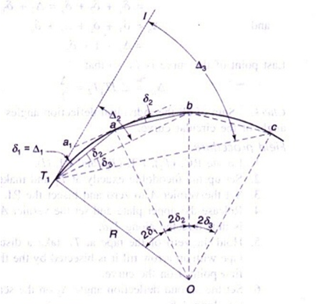

Fig.-Rankine’s method of deflection curve

**Result:** The simple curve was set by Rankin’s method of tangential angles.

**Questions**

1. Different grades are joined together by a

a) Compound curve

b) Transition curve

c) Reverse curve

d) Vertical curve

|  |  |
| --- | --- |
|  | 2.When the curve is to be set out over a rough ground, the method used is |
| |  |  |  |  | | --- | --- | --- | --- | | [**A.**](javascript:%20void%200;) | Rankine's method | [**B.**](javascript:%20void%200;) | two theodolite method | | [**C.**](javascript:%20void%200;) | tacheometric method | [**D.**](javascript:%20void%200;) | either (b) or (c) | |

1. The deflection angle for any chord is equal to the deflection angle for the proceeding chord minus the tangential angle for that chord. **(True or False)**

|  |
| --- |
| 1. The curve used for ideal transition curve is a |
| |  |  |  |  | | --- | --- | --- | --- | | [**A.**](javascript:%20void%200;) | cubic parabola | [**B.**](javascript:%20void%200;) | clothoid spiral | | [**C.**](javascript:%20void%200;) | cubic spiral | [**D.**](javascript:%20void%200;) | lemniscates | |

|  |  |
| --- | --- |
| 1. A transition curve when inserted between the tangent and the circular curve | |
| |  |  |  |  | | --- | --- | --- | --- | | [**A.**](javascript:%20void%200;) | should meet the original straight tangentially | [**B.**](javascript:%20void%200;) | should meet the circular curve tangentially | | [**C.**](javascript:%20void%200;) | the rate of increase of curvature along the transition curve should be same as that of increase of super-elevation | [**D.**](javascript:%20void%200;) | all of the above | | |
|  | 6. The curve of varying radius is known as |
| |  |  |  |  | | --- | --- | --- | --- | | [**A.**](javascript:%20void%200;) | simple curve | [**B.**](javascript:%20void%200;) | compound curve | | [**C.**](javascript:%20void%200;) | reverse curve | [**D.**](javascript:%20void%200;) | transition cruve | |

7. What do you mean by Degree of curve?

**EXPERIMENT NO – 10**

**OBJECT:** To plot the contour map for a given area by direct method.

**Eqipments:** Dumpy Level, Levelling Staff, Tripod, Staff bubble, Chain or Tape.

**Procedure:**

1. First, ensure that an appropriate bench mark (BM) is available near the site of the survey. If a B.M is not available, then one should be located near the site by fly leveling.

2. Once a benchmark is available, set up the instrument (level) at a suitable position covering a large part of the area to be surveyed.

3. The area is divided into a number of squares and all grid points are marked (Ref. Fig. 1). Commonly used size of square varies from 5 m × 5 m to 20 m × 20 m.

4. Levels of all grid points are established by leveling.

5. Then **grid square** is plotted on the drawing sheet. Reduced levels of grid points marked

and contour lines are drawn by interpolation [Ref. Fig. 1].

  
 Figure 1: Grid Contouring