BBDNITM
MECHANICAL DEPARTMENT
SESSION (2018-19)
COMPUTER AIDED MANUFACTURING (NME 031)
Assignment No.-4
1. List out the types of CNC machine?
2. Write short notes on Absolute and Incremental Coordinate System.
3. What are Geometric, Auxilary Statement in APT?
4. Define various NC words used in WAF.
5. Explain the term – G91, G01, G21, M03, M13
6. The workpart of Figure (1) is to be completed in an NC drill press. The outline of the part has already been completed and the five holes are to be drilled. The axis system for this sequence is to be located with the origin at the lower left-hand corner of the part. The part is 10 mm thick.
- Write the APT geometry statements to define the hole locations.
- Write the sequence of motion statements in APT to perform the drilling sequence. Use a point at x = −1 and y = −3 as the target point for the FROM statement.
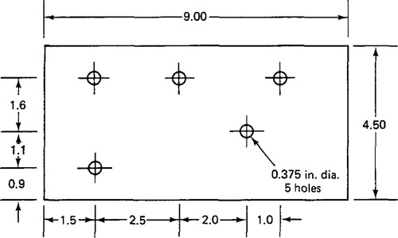

Fig.1

