BBDNITM
MECHANICAL ENGG. DEPARTMENT
SESSION (2018-19)
Subject- Mechanics of Solids [RME303]
Assignment – 5
- Define Unsymmetrical bending.
- What are the conditions to consider a bending as unsymmetrical bending?
- Define shear centre.
- Write the shear centre equation for channel section.
- A channel Section has flanges 12 cm x 2 cm and web 16 cm x 1 cm. Determine the
shear centre of the channel.
- Write the shear centre equation for unsymmetrical I section.
- State the assumptions made in Winkler’s Bach Theory.
- Define stress concentration.
- Explain the position of shear centre in various sections.
- State the principles involved in locating the shear centre.
- Derive the equation of Shear centre for channel section.
- Derive the equation of Shear center for unequal I-section.
- Fig.13A shows a frame subjected to a load of 2.4 kN. Find
  - The resultant stresses at a point 1 and 2;
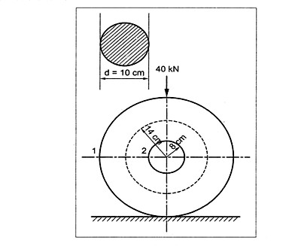
  - Position of neutral axis.
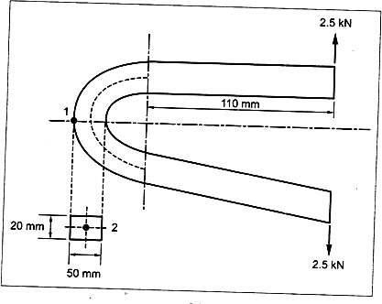
Fig:13A Fig:14A
- Fig.14A shows a ring carrying a load of 30 kN. Calculate the stresses at 1 and 2.
- A curved bar is formed of a tube of 120 mm outside diameter and 7.5 mm thickness. The centre line of this is a circular arc of radius 225 mm. The bending moment of 3 kNm tending to increase curvature of the bar is applied. Calculate the maximum tensile and compressive stresses set up in the bar.
- A cured bar of rectangular section, initially unstressed is subjected to bending moment of 2000N –m tends to straighten the bar .The section is 5cm wide and 6cm deep in the plane of bending and mean radius of curvature is 10cm . Find the position of neutral axis and the stress at the inner and outer face.

